### **Part 2: Create Reports, Alerts, and Dashboards for the Windows Logs**

REPORTS

1. A report with a table of signatures and associated signature IDs:

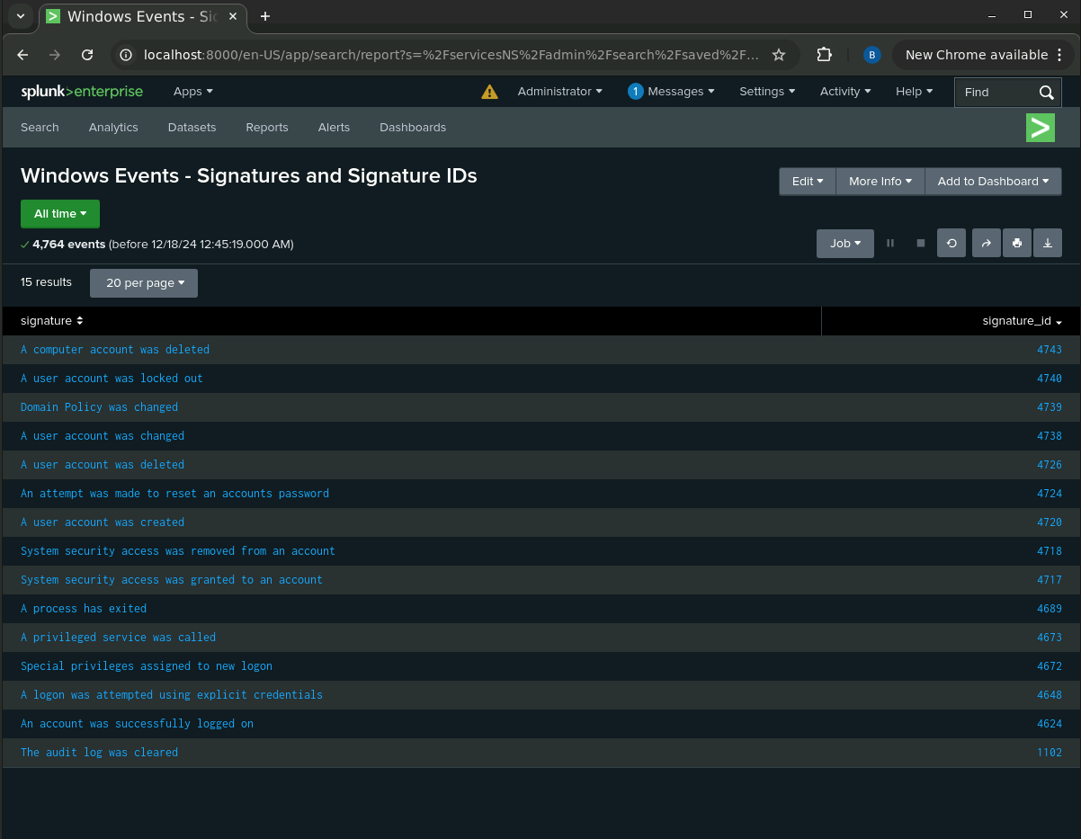

1. A report that displays the severity levels, and the count and percentage of each:

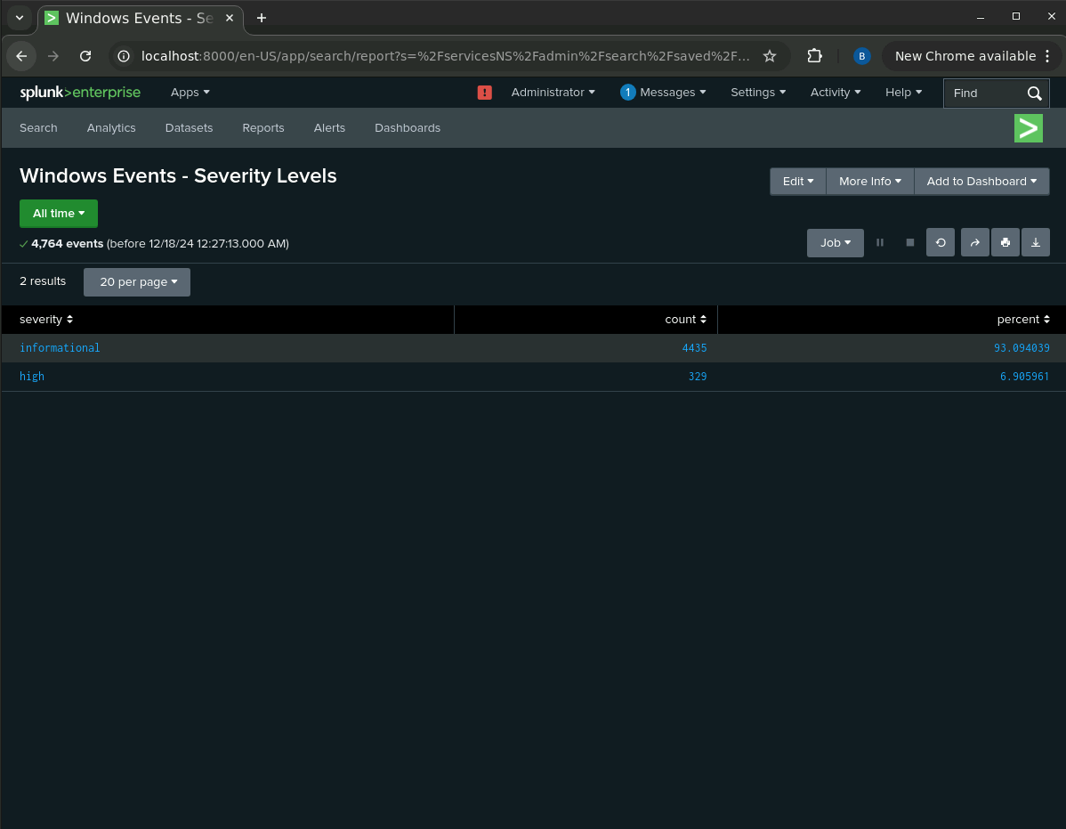

1. A report that provides a comparison between the success and failure of Windows activities:

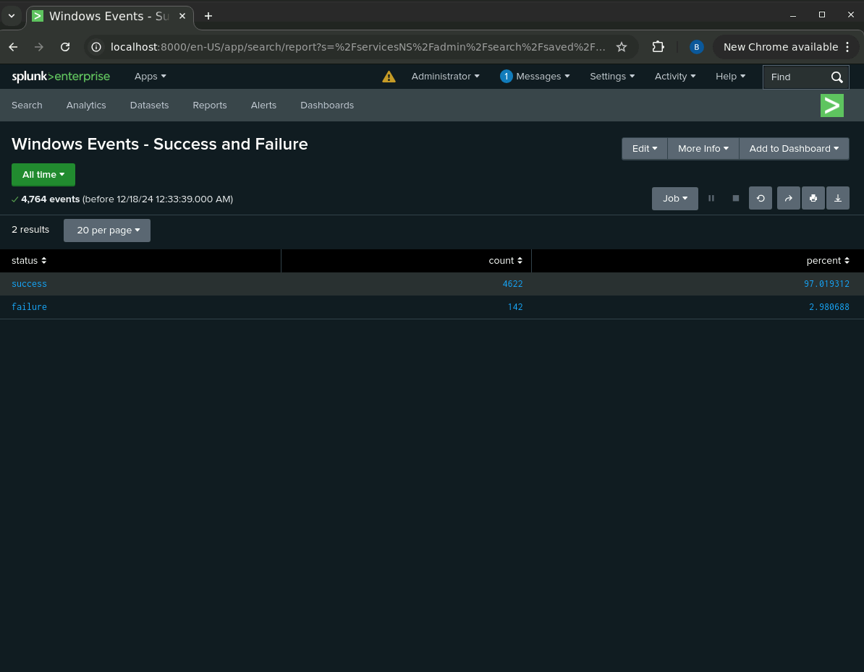

Visualizations and dashboards

A line chart that displays the different “signature” field values over time.

source="windows_server_logs.csv"| timechart span=1h count by signature

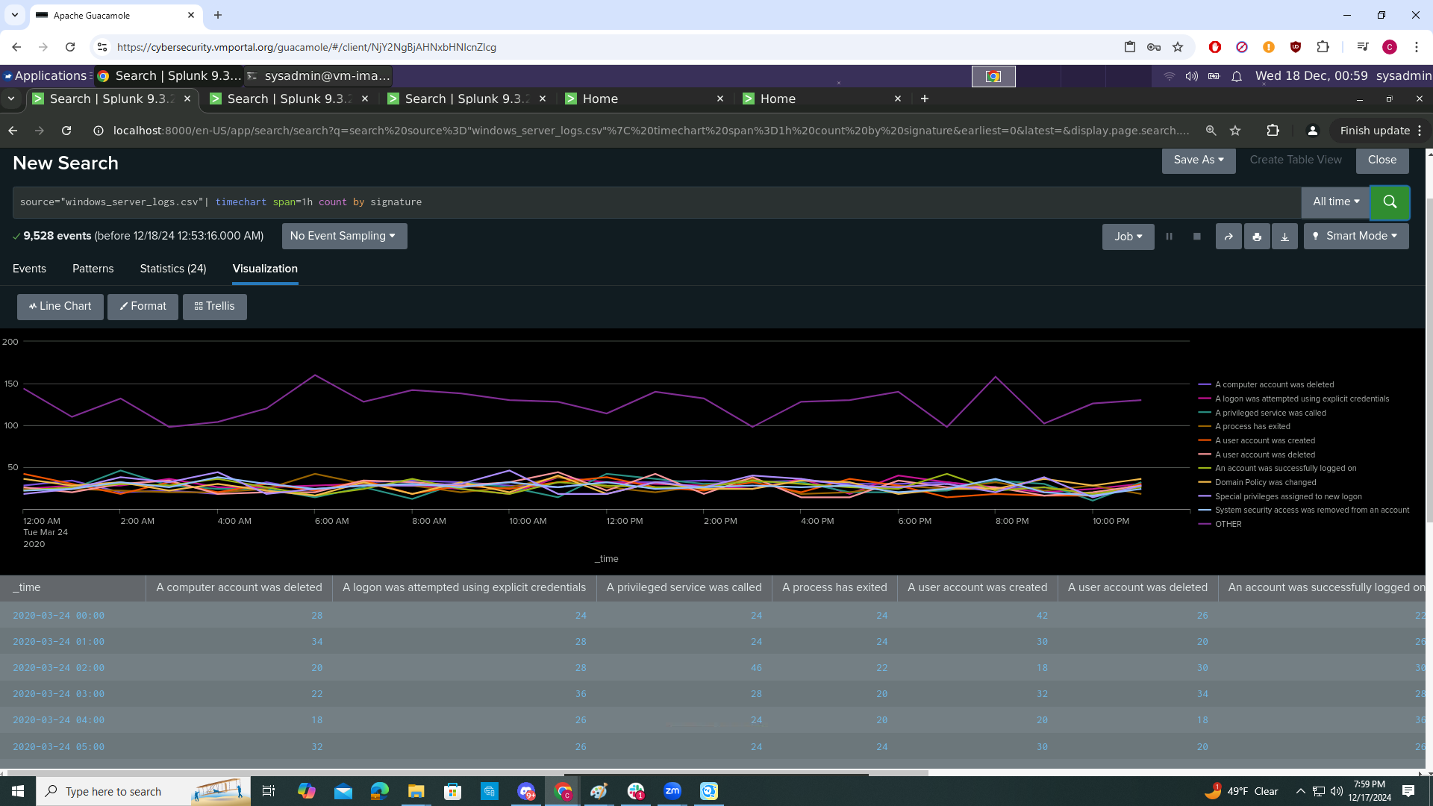

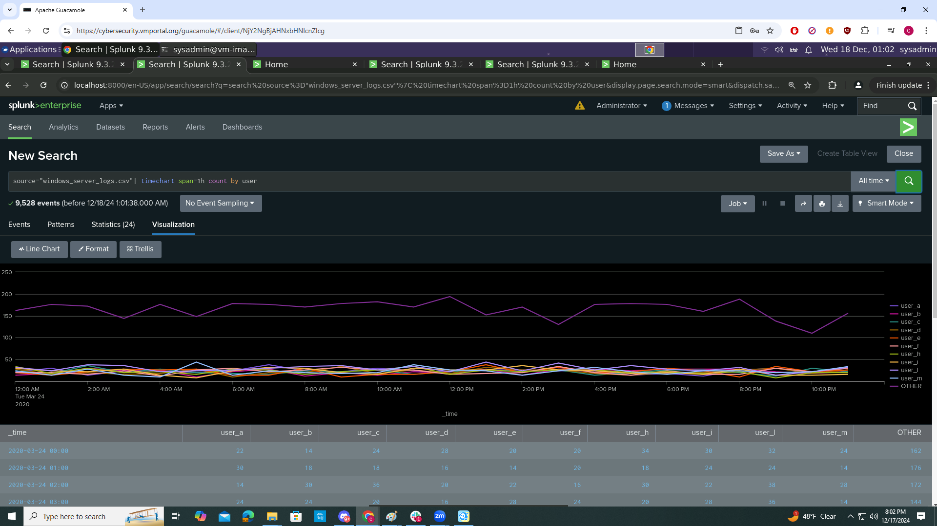

Any visualization that illustrates the count of different signatures

source="windows_server_logs.csv"| stats count by signature

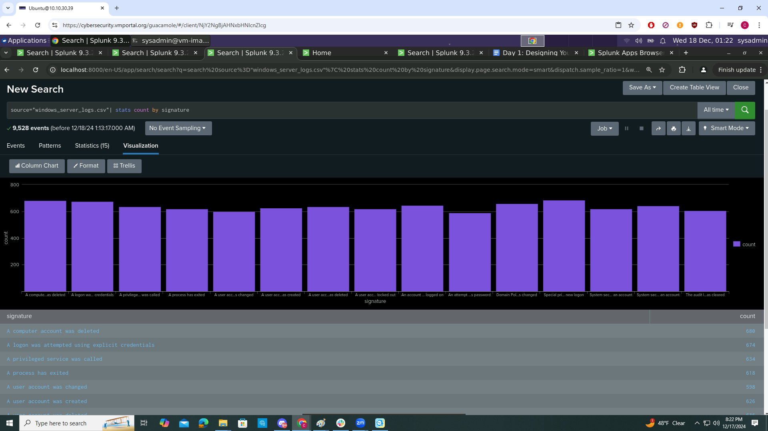

Any visualization that illustrates the count of different users

source="windows_server_logs.csv" | stats count by user

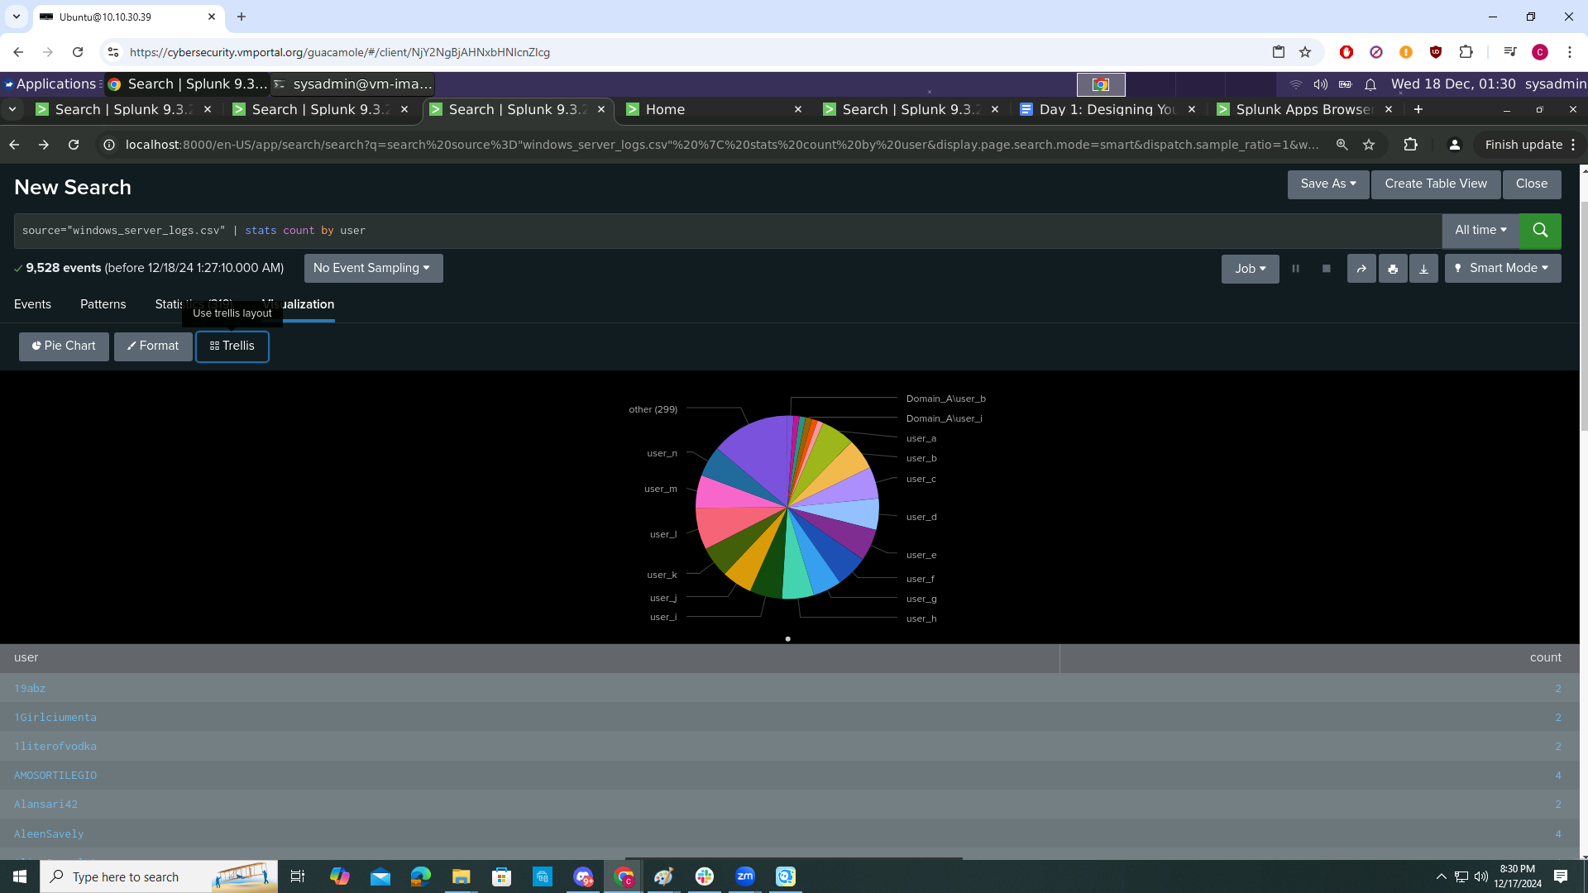

Any single-value visualization of your choice that analyzes any single data

source="windows_server_logs.csv" |top limit=10 EventCodeDescription

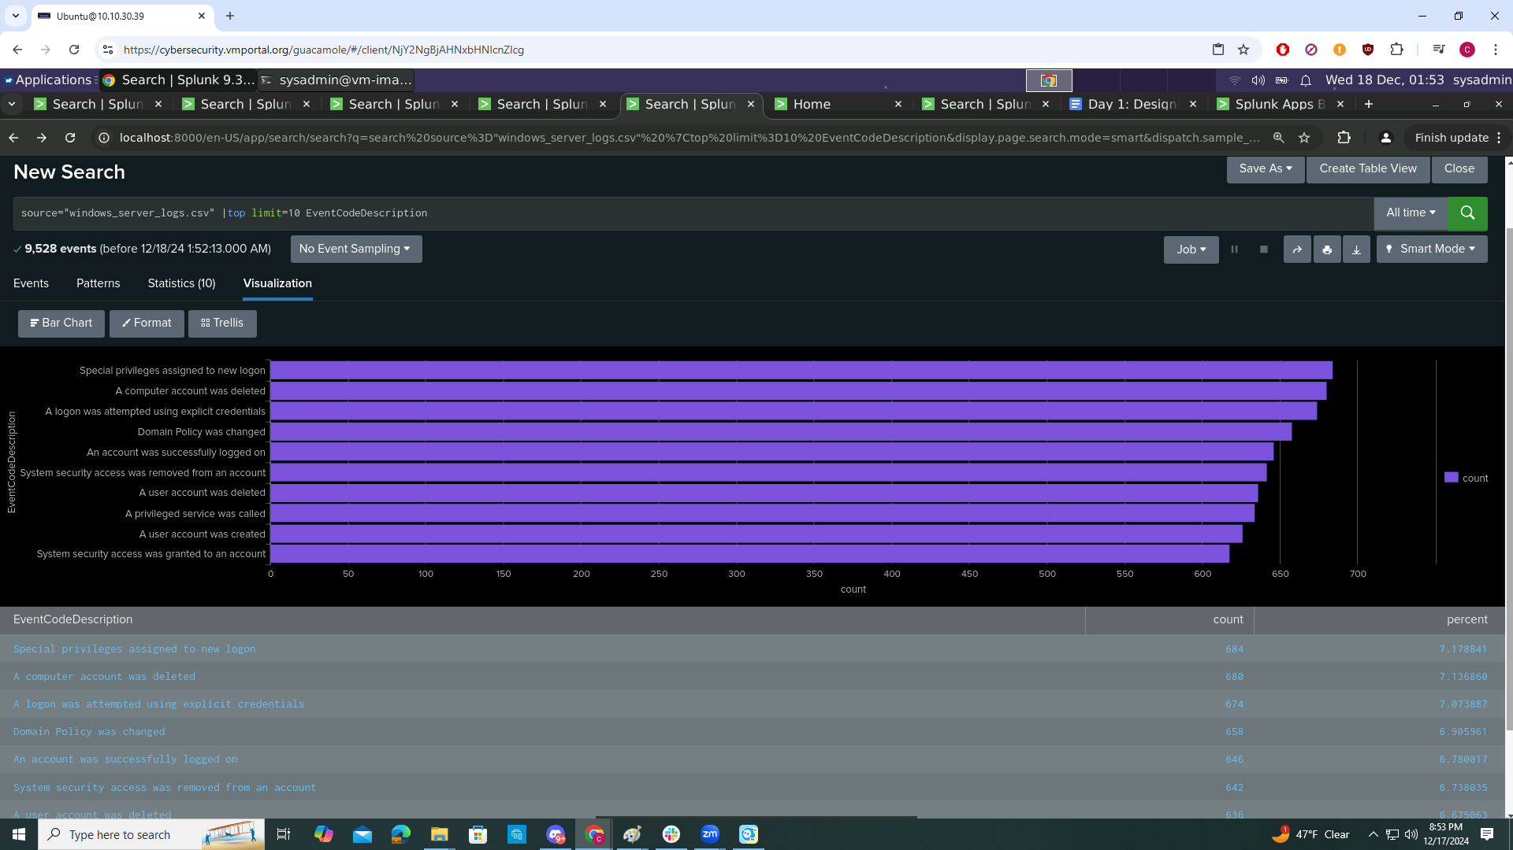

On your dashboard, add the ability to change the time range for all visualizations.

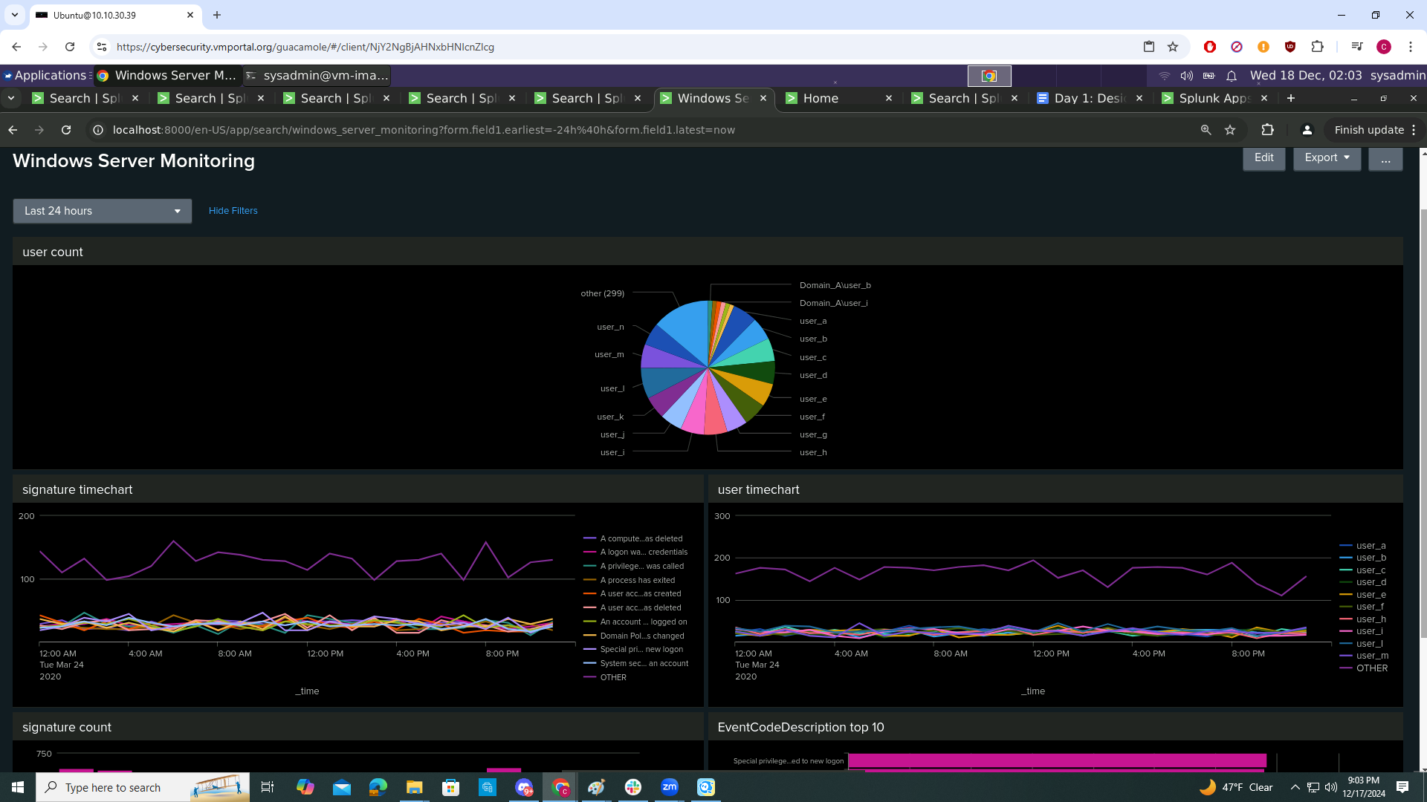

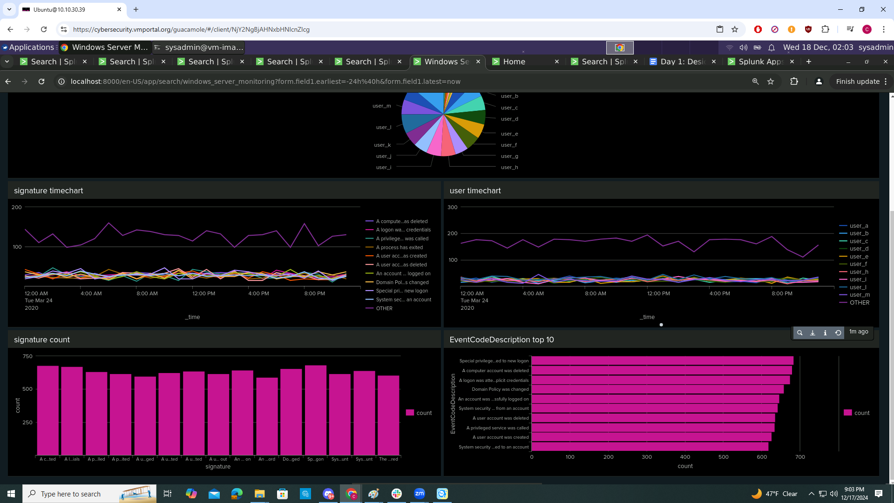

ALERTS

1. Determine a baseline and threshold for the hourly level of failed Windows activity:
   1. Average = 6 failures per hour
   2. Maximum = 10 failures per hour
   3. Recommended Threshold = 12 failures per hour

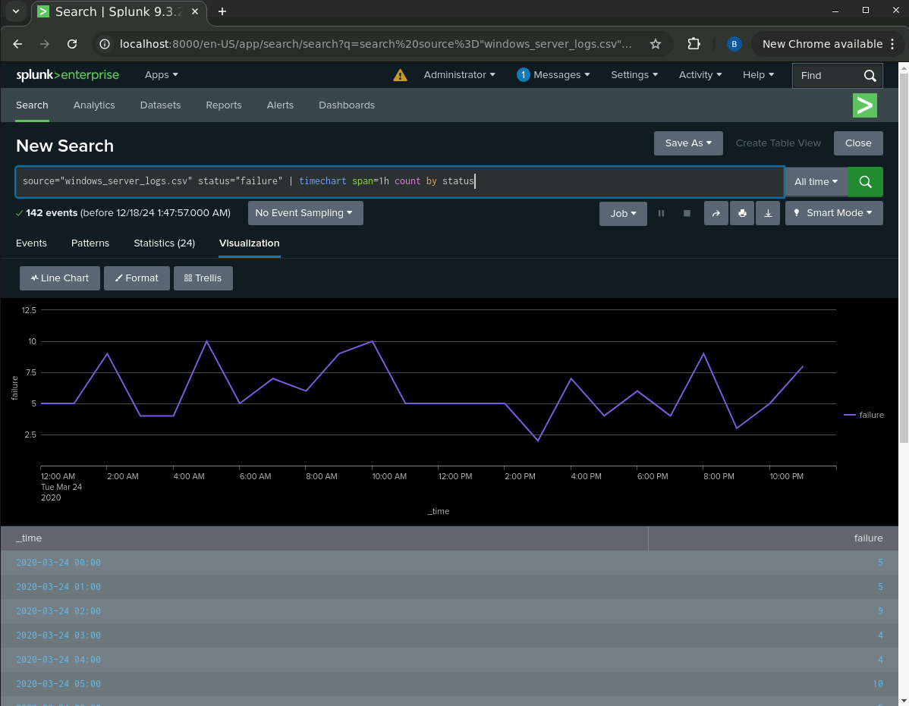

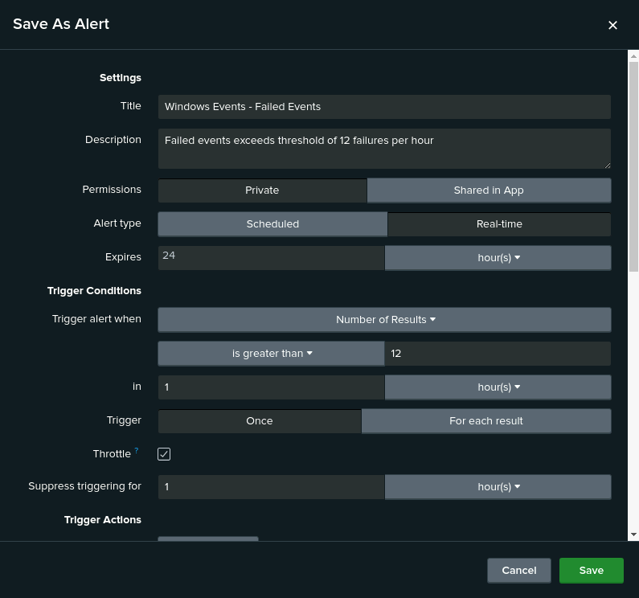

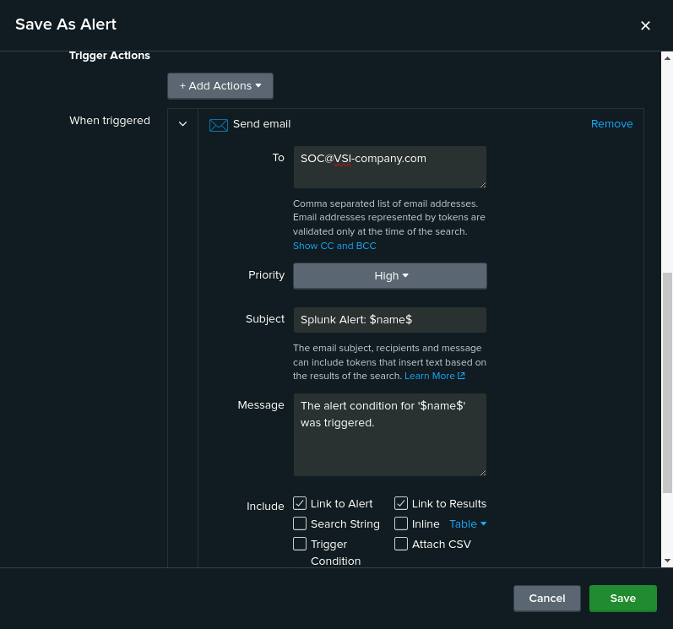

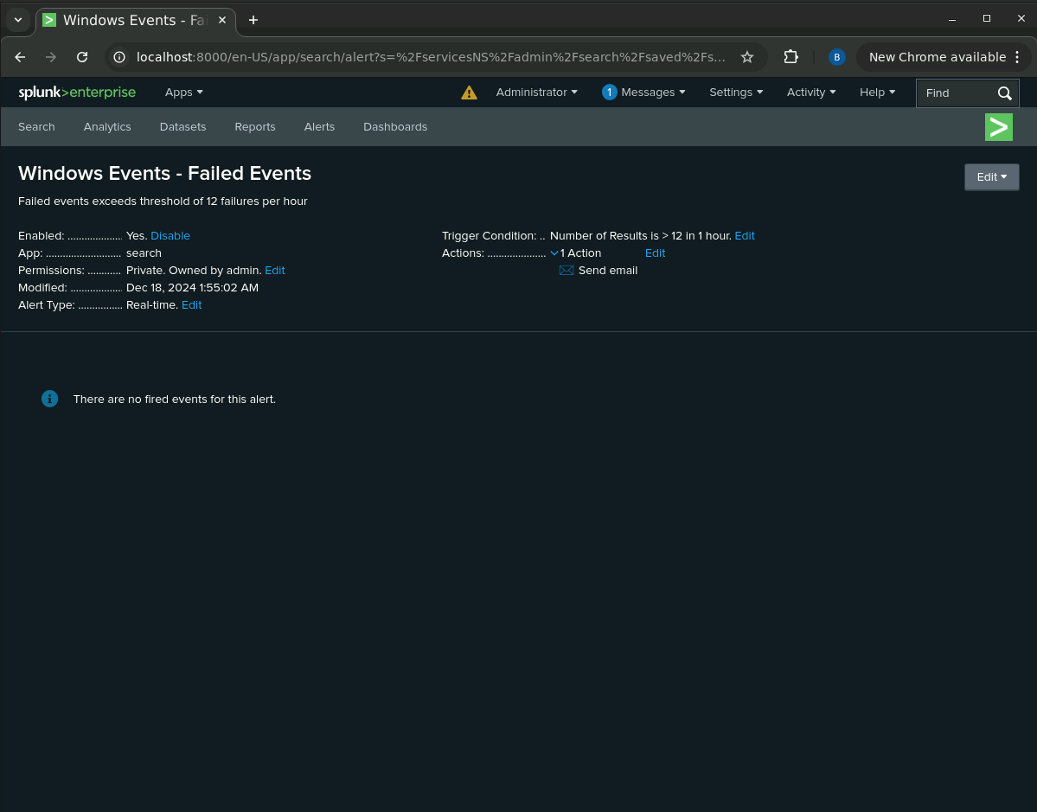

1. Determine a baseline and threshold for the hourly count of the signature “an account was successfully logged on.”
   1. Average = 3 successful logins per hour per user
   2. Maximum = 6 successful logins per hour by user_a
   3. Recommended Threshold = 8 successful logins per hour per user

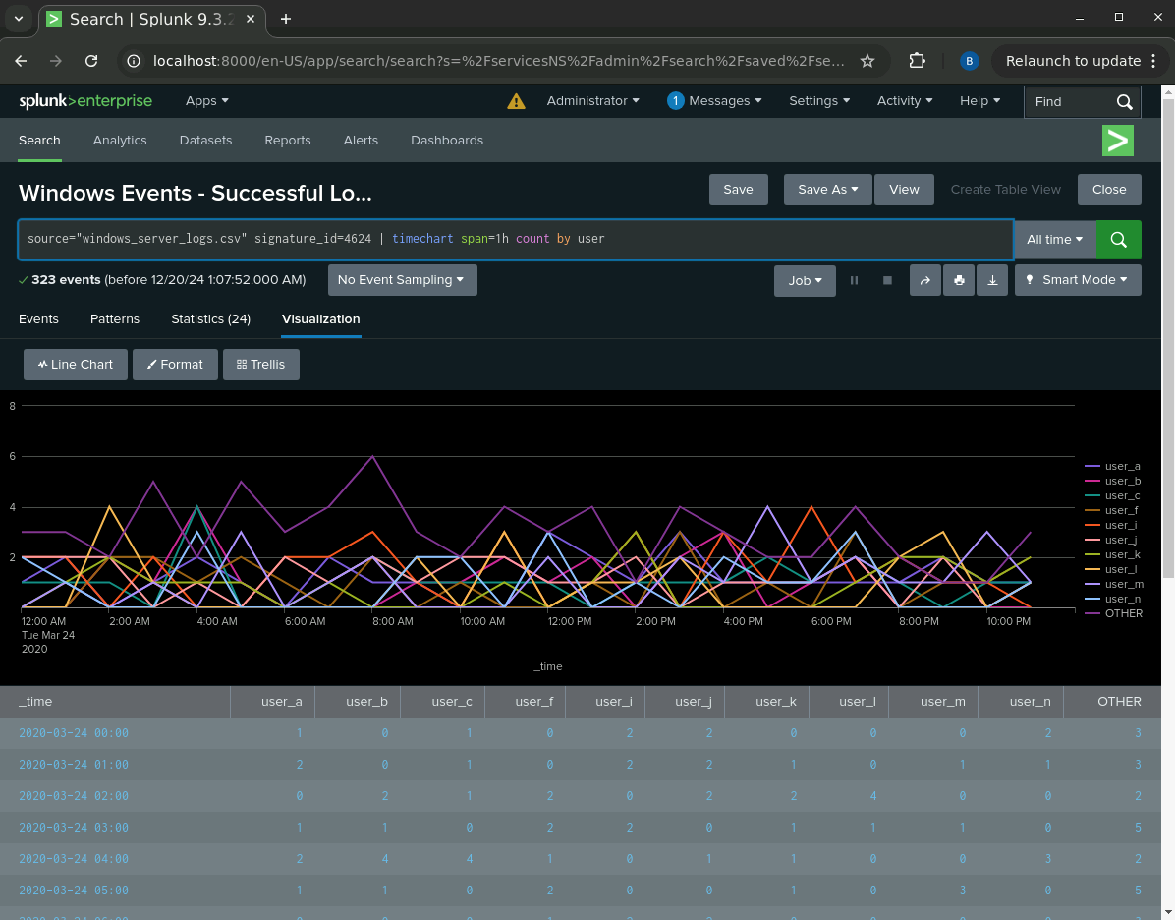

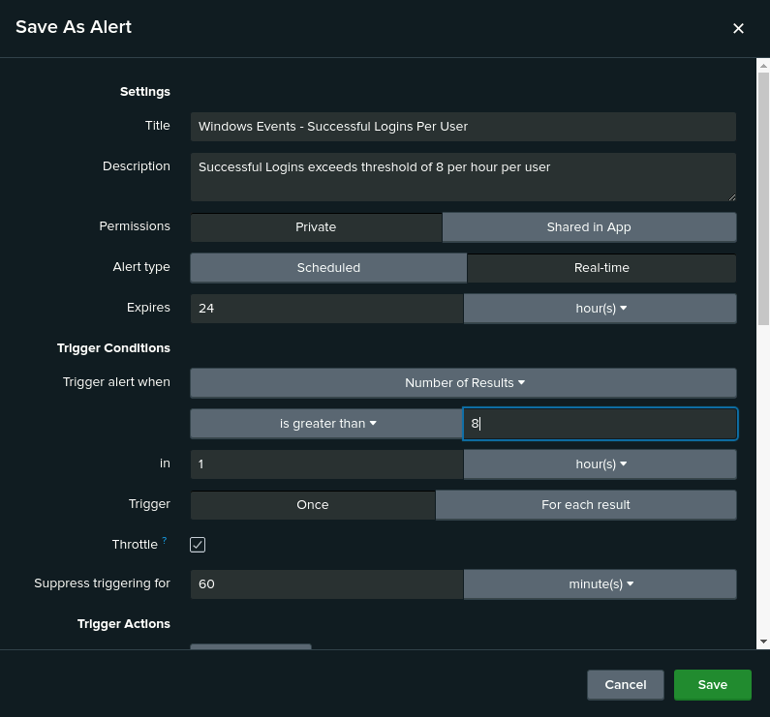

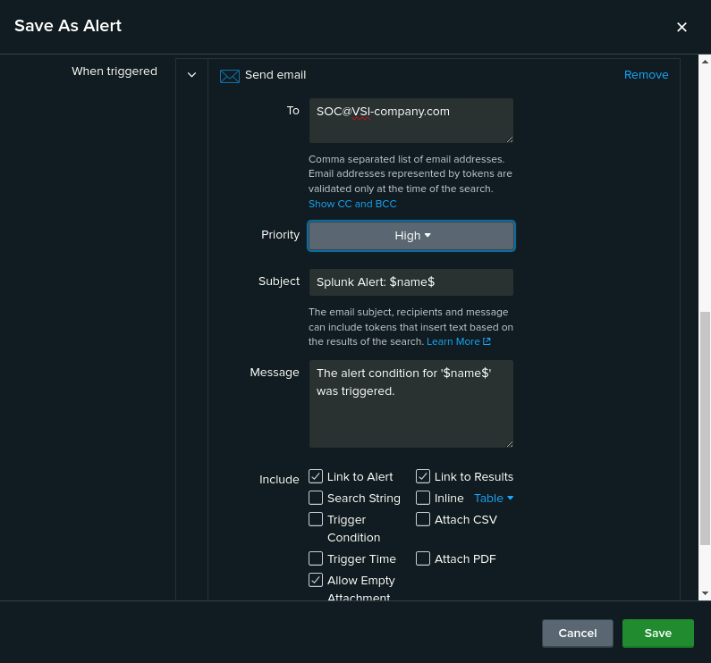

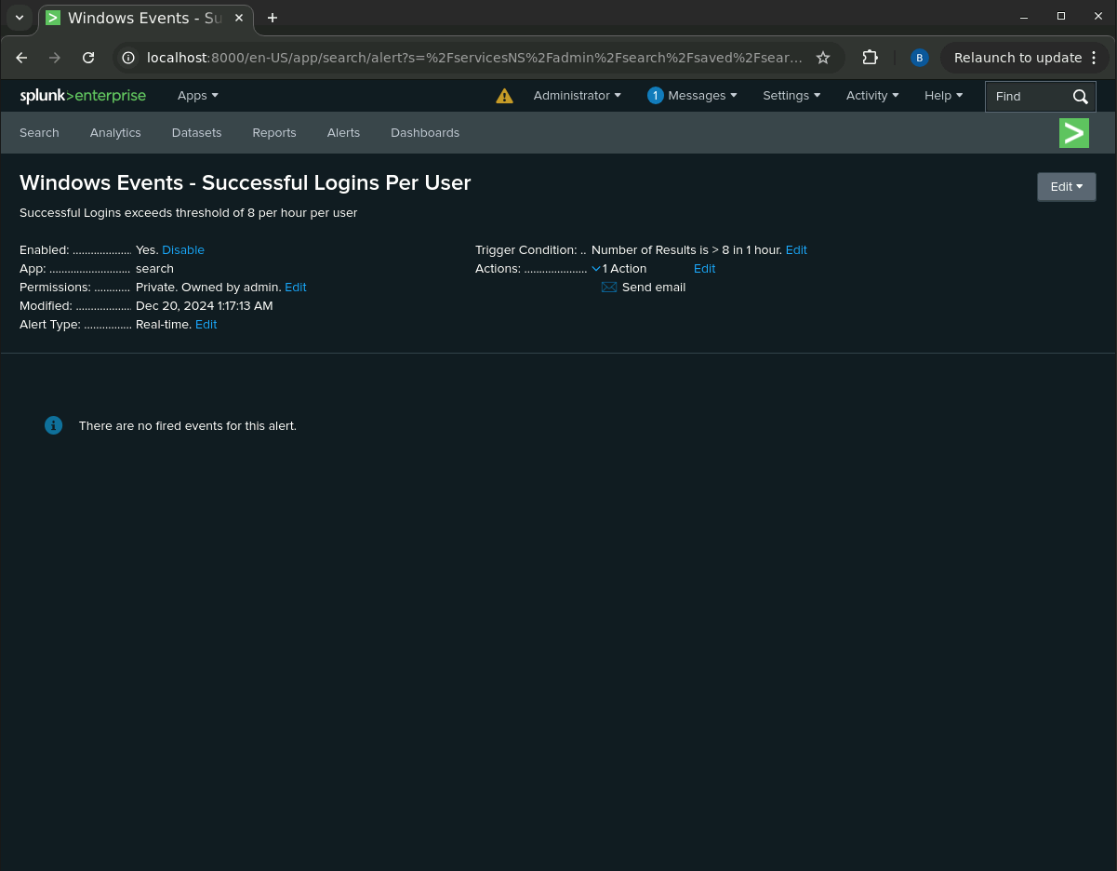

1. Determine a baseline and threshold for the hourly count of the signature “a user account was deleted.”
   1. Average = 13 user accounts deleted per hour
   2. Maximum = 22 user accounts deleted per hour
   3. Recommended Threshold = 26 user accounts deleted per hour

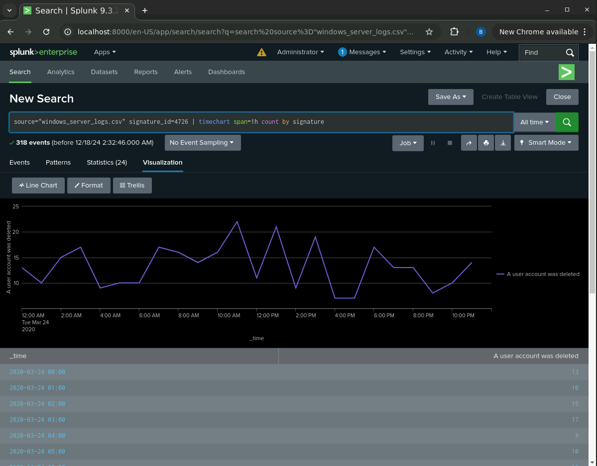

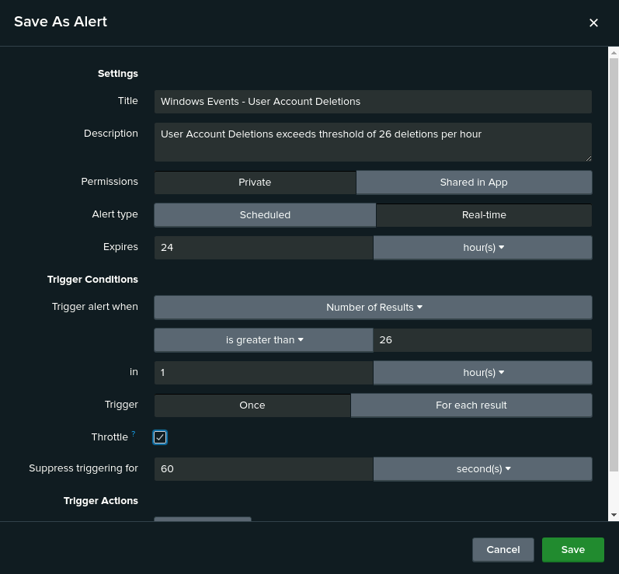

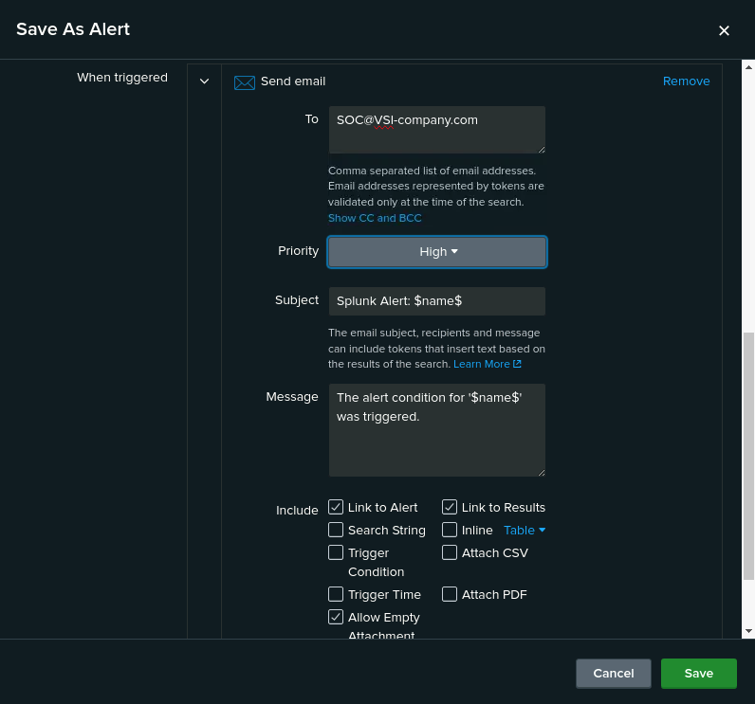

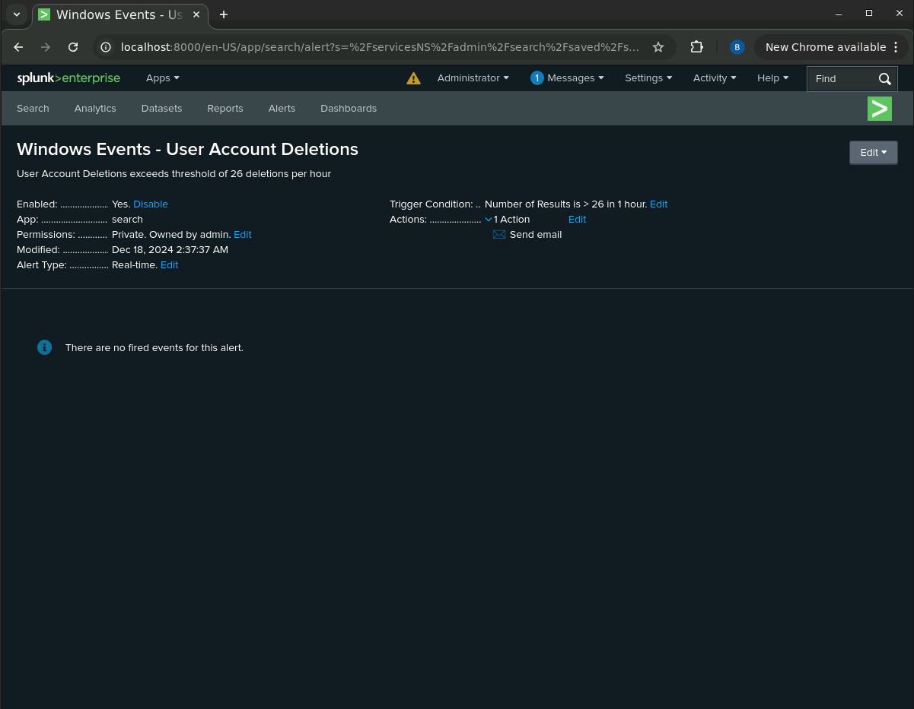

Apache

* + 1. A report that shows a table of the different HTTP methods (GET, POST, HEAD, etc.).

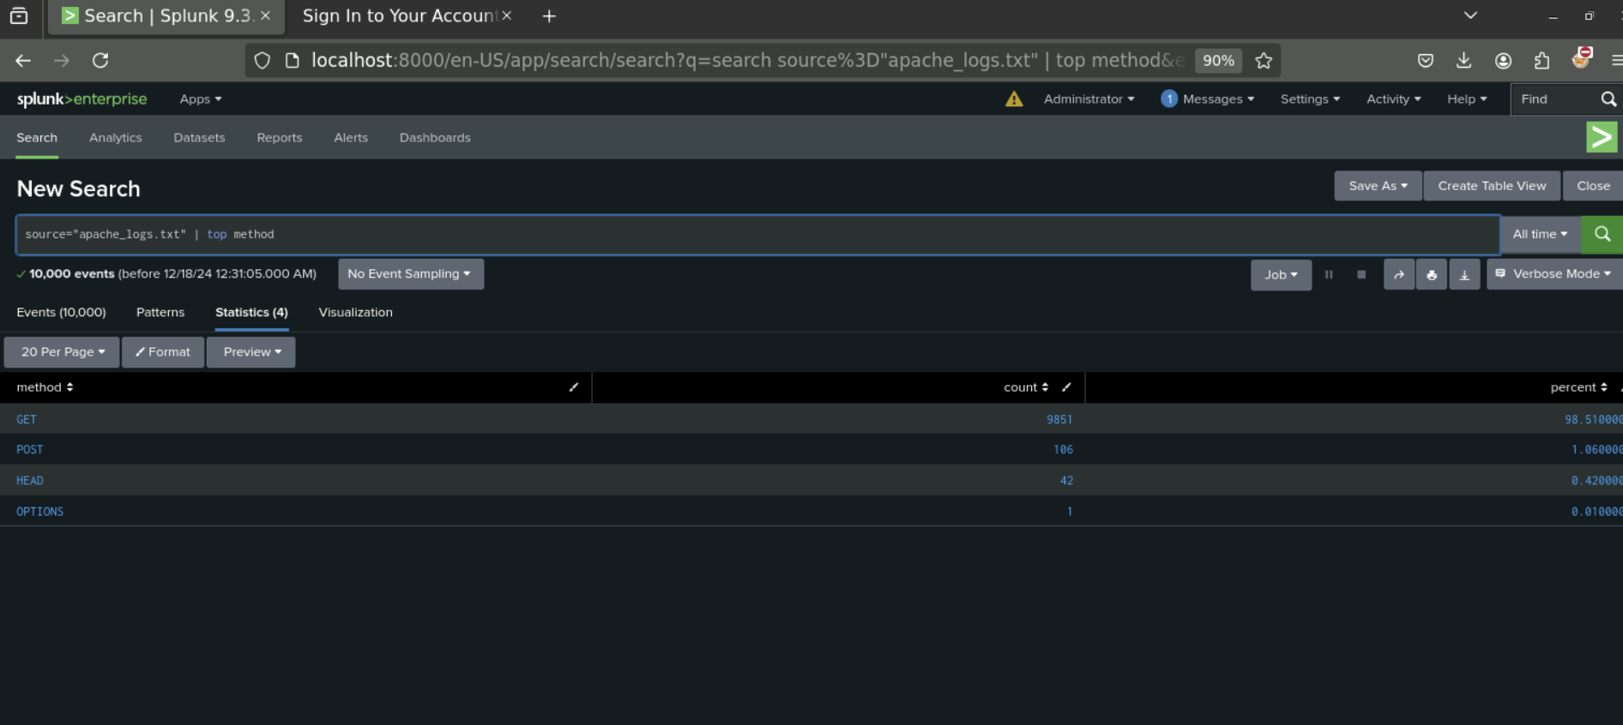

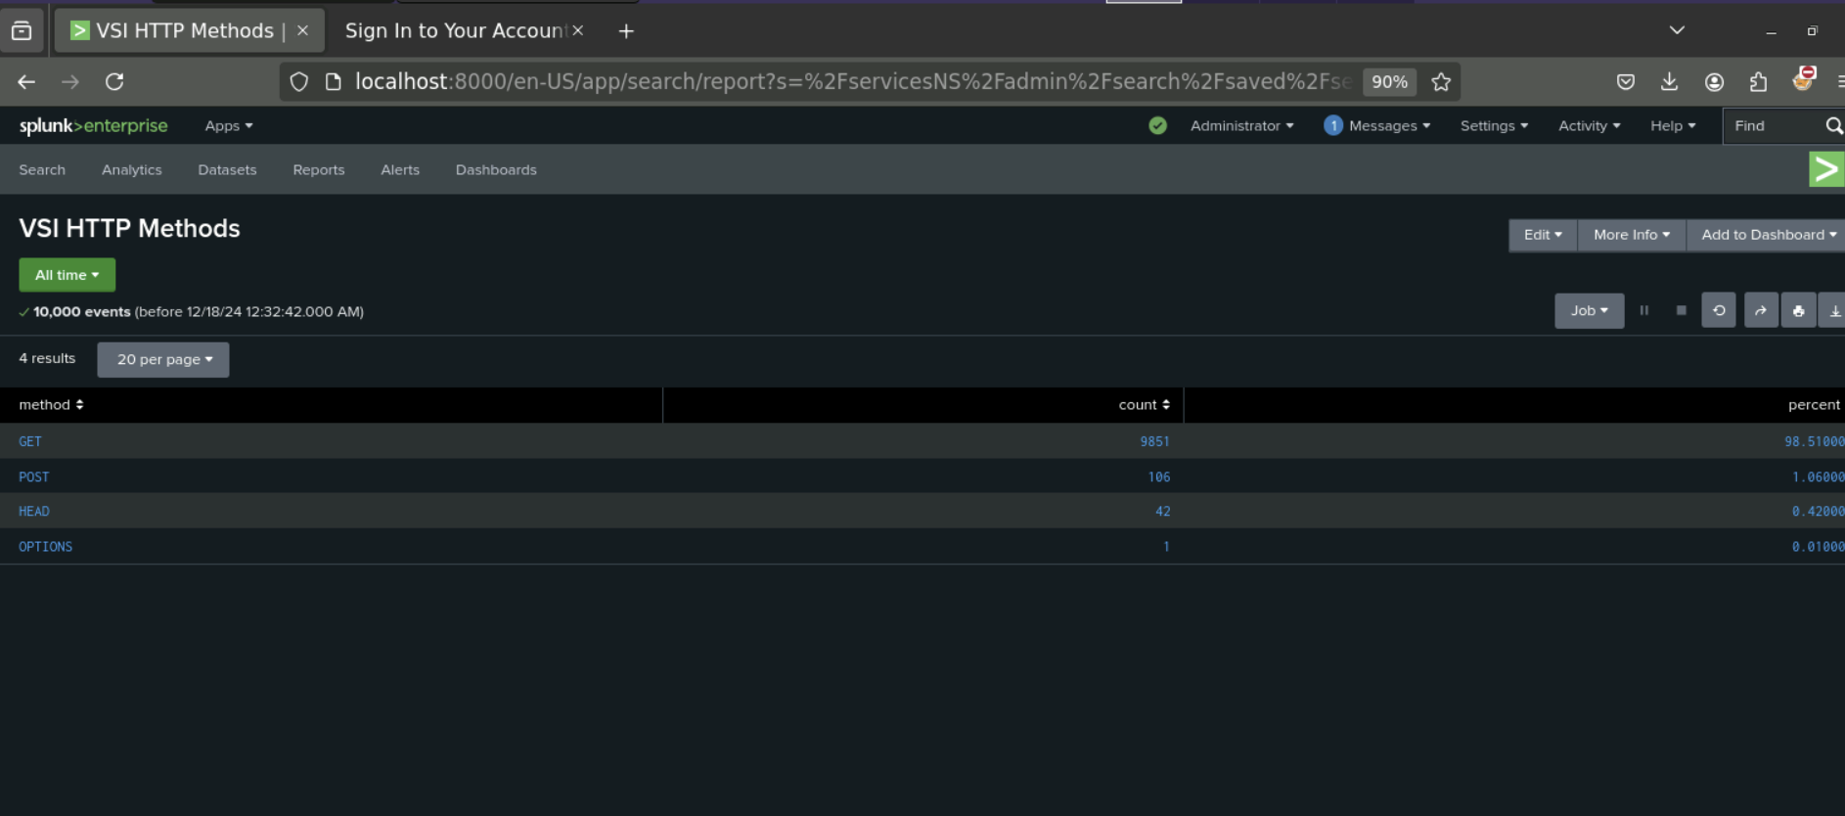

* + 1. A report that shows the top 10 domains that refer to VSI’s website.

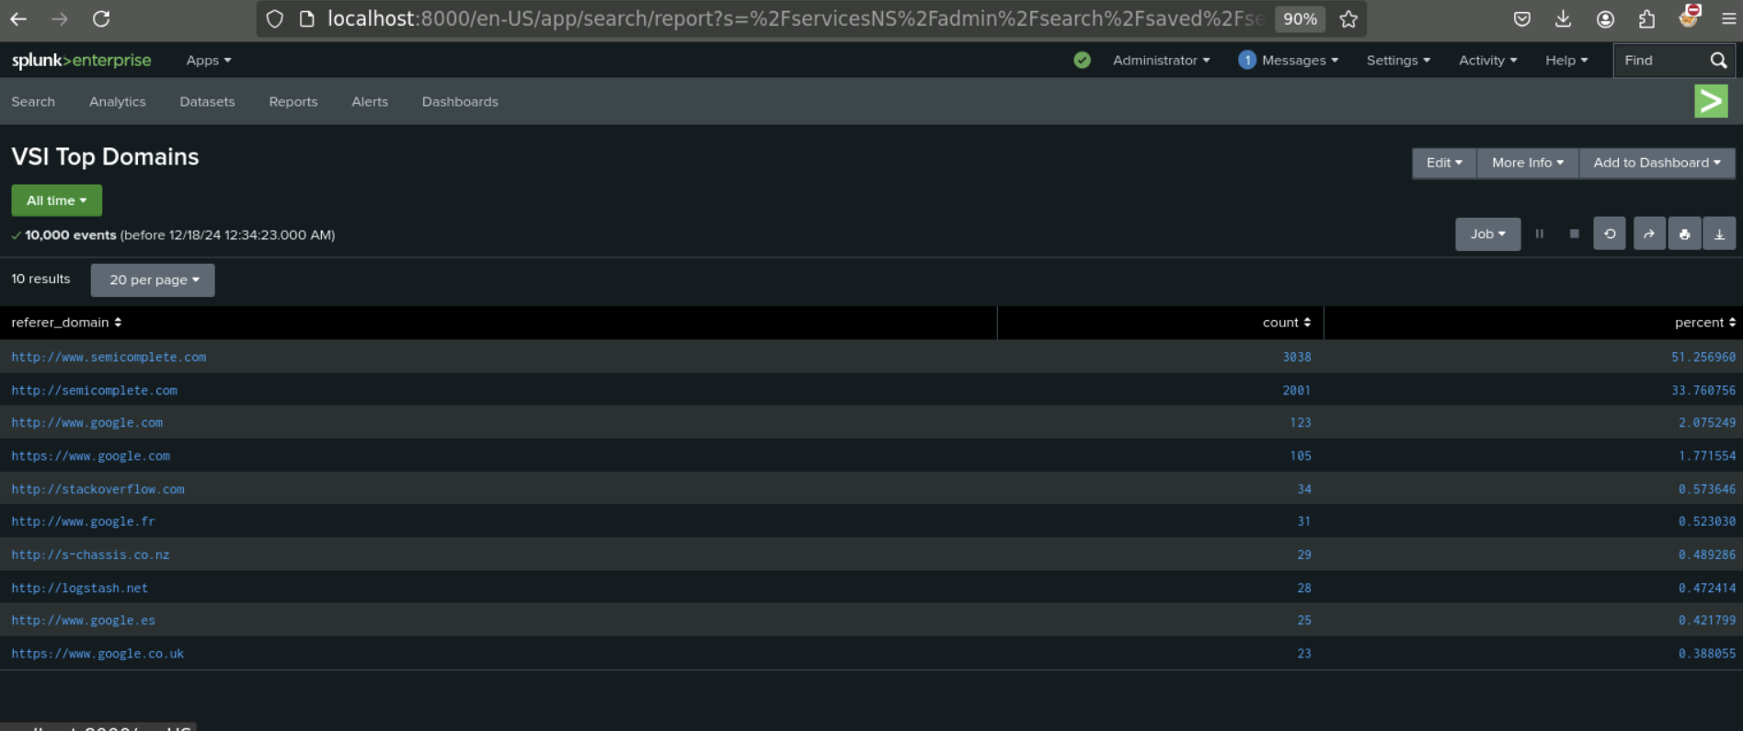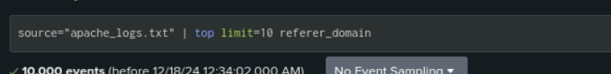

* + 1. A report that shows the count of each HTTP response code.

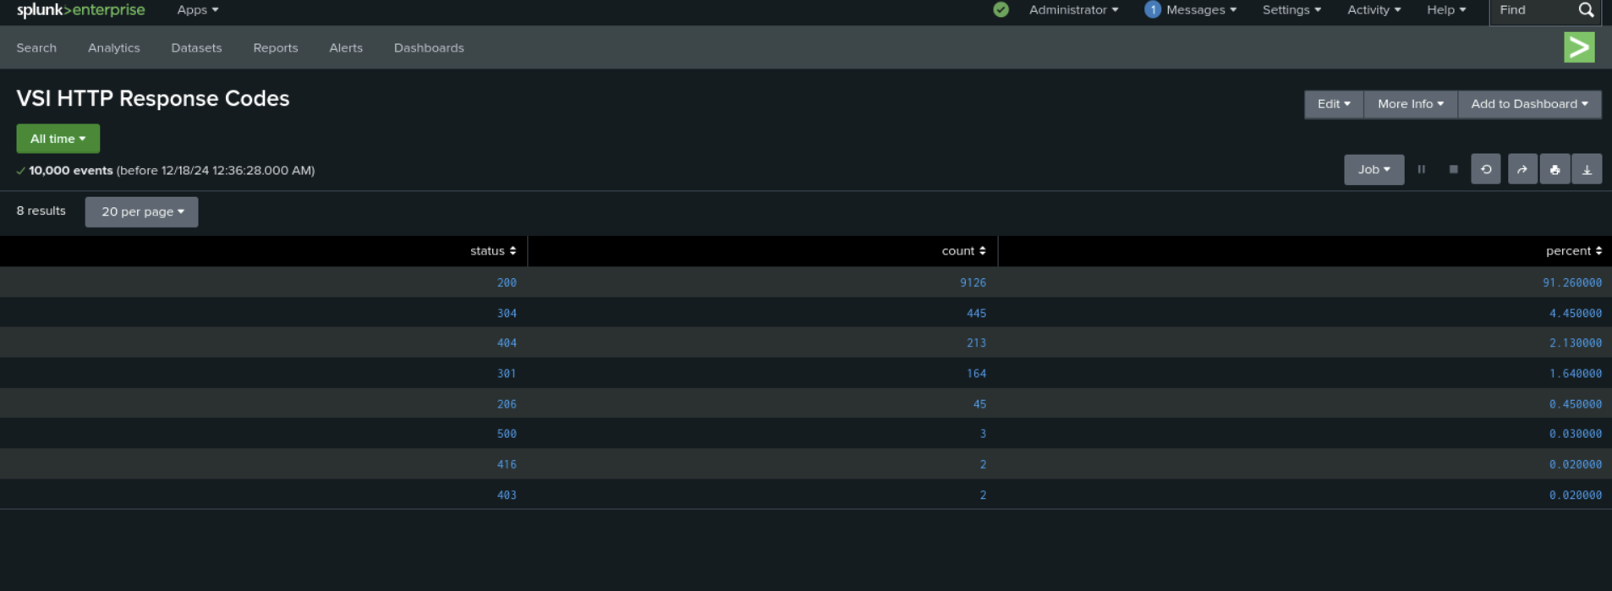

* + **Alerts:** Design the following **alerts**:
    1. Determine a baseline and threshold for hourly activity from any country besides the United States.
       - Create an alert that’s triggered when the threshold has been reached.

80 is the baseline and 170 is the threshold

* + - * The alert should trigger an email to [SOC@VSI-company.com](mailto:SOC@VSI-company.com).

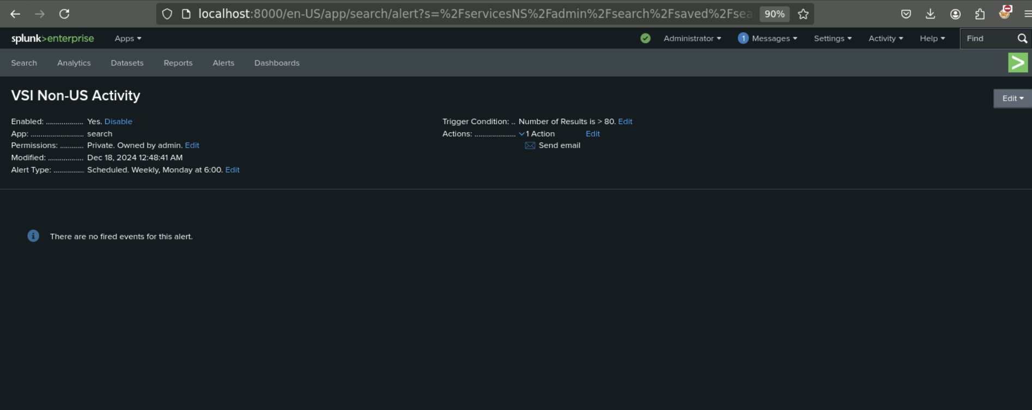

* + 1. Determine an appropriate baseline and threshold for the hourly count of the HTTP POST method.
       - Create an alert that’s triggered when the threshold has been reached.
       - The alert should trigger an email to [SOC@VSI-company.com](mailto:SOC@VSI-company.com).

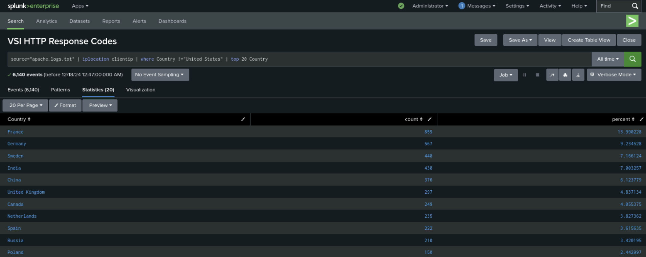

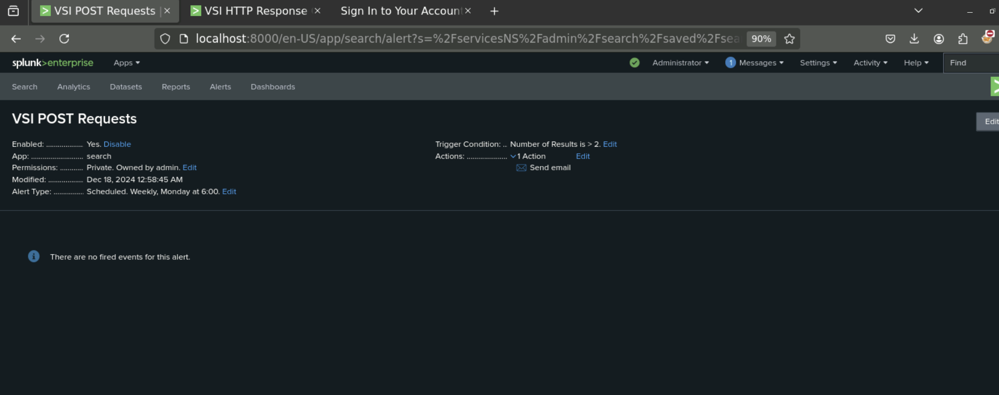

* + **Visualizations and dashboards:** Design the following **visualizations**, and add them to a **dashboard** called “Apache Web Server Monitoring” (be creative with your visualizations, and make sure to grab screenshots of each):
    1. A line chart that displays the different HTTP “methods” field values over time.
       - **Hint:** Add the following after your search: timechart span=1h count by method.

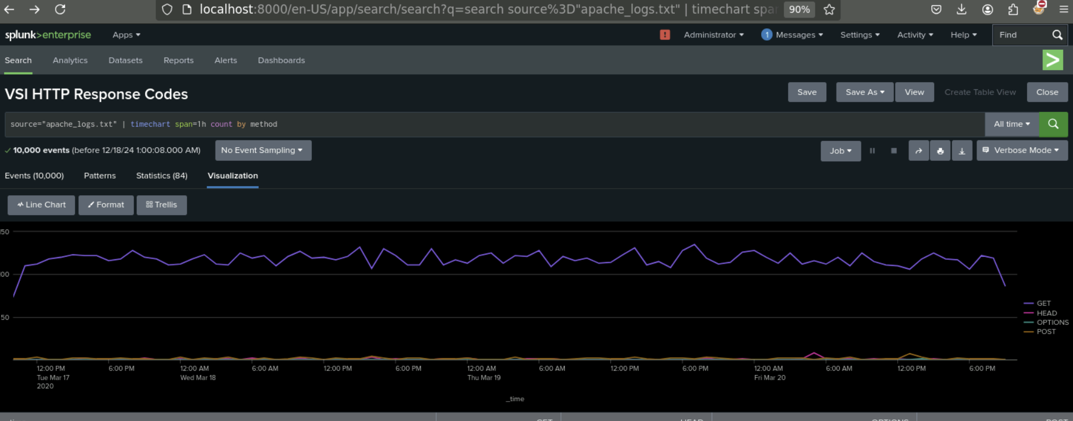

* + 1. A geographical map showing the location based on the “clientip” field.

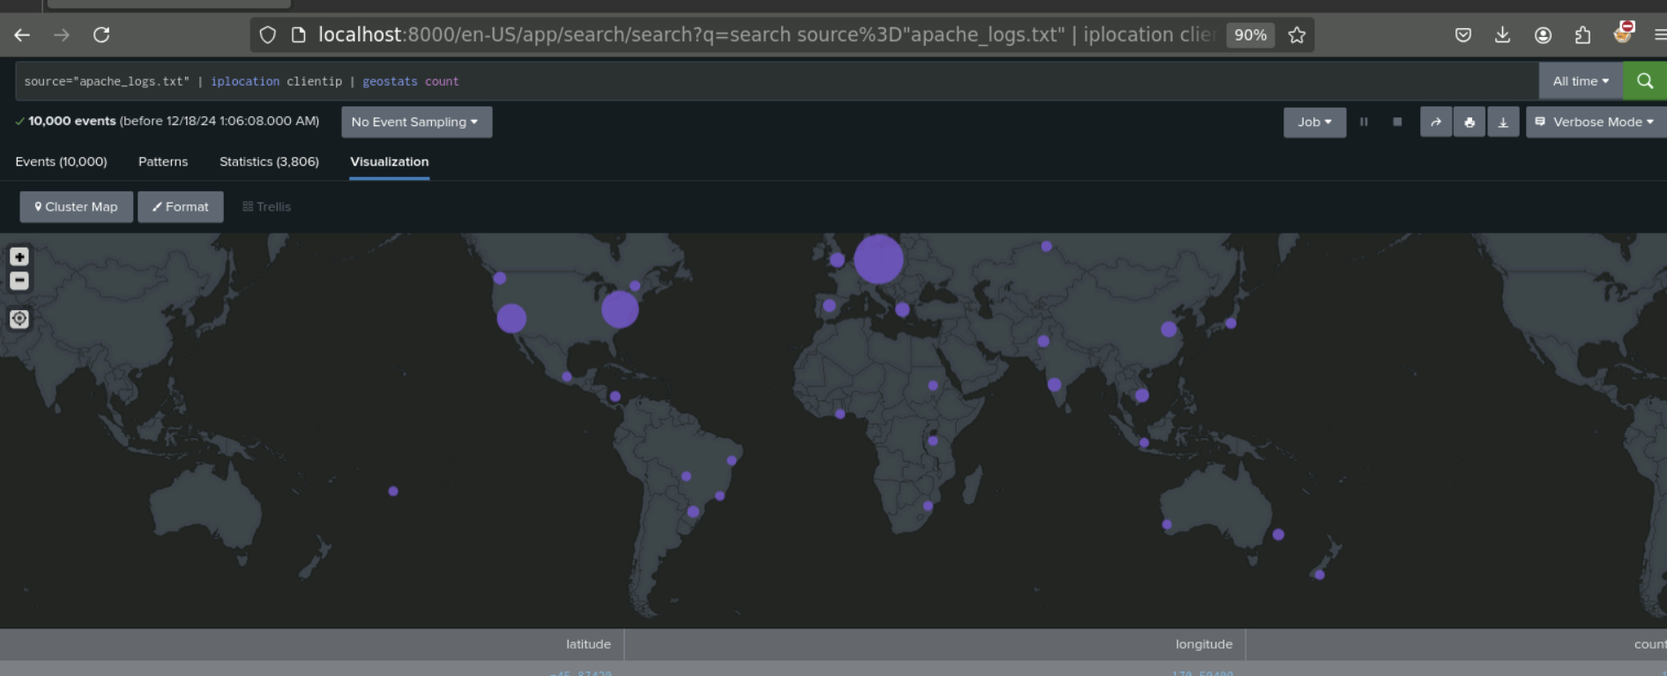

* + 1. Any visualization of your choice that displays the number of different URIs.
       - **Hint:** You can add brand-new custom visualizations by accessing this page inside your VM: [Additional Viz](http://localhost:8000/en-US/manager/search/appsremote?content=visualizations&type=app).

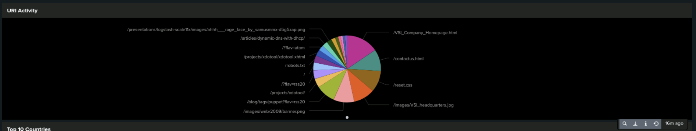

* + 1. Any visualization of your choice that displays the count of the top 10 countries that appear in the log.

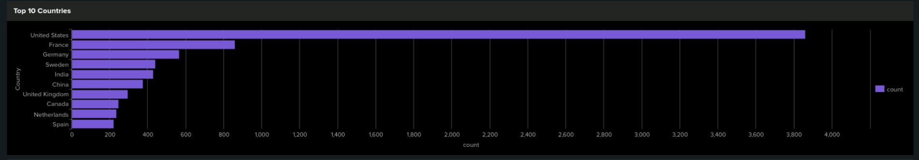

* + 1. Any visualization that illustrates the count of different user agents.

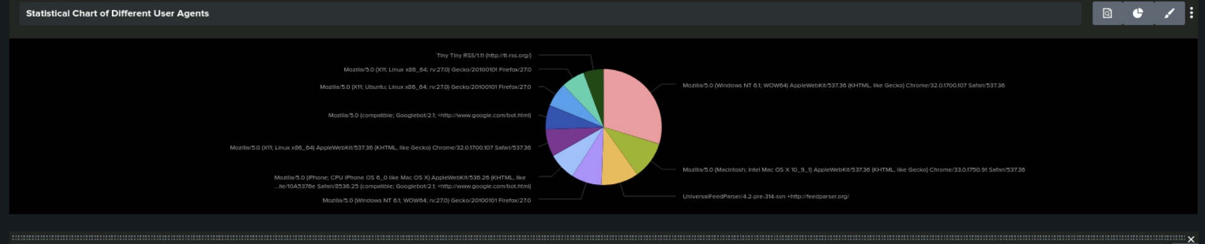

* + 1. A single-value visualization of your choice that analyzes any single data point: e.g., radial gauge, marker gauge, or a custom visualization from <http://localhost:8000/en-US/manager/search/appsremote?content=visualizations&type=app>).



1. On your dashboard, add the ability to change the time range for all visualizations.
   * Be sure to title all of your panels appropriately.
   * Organize the panels on your dashboard as you see fit.

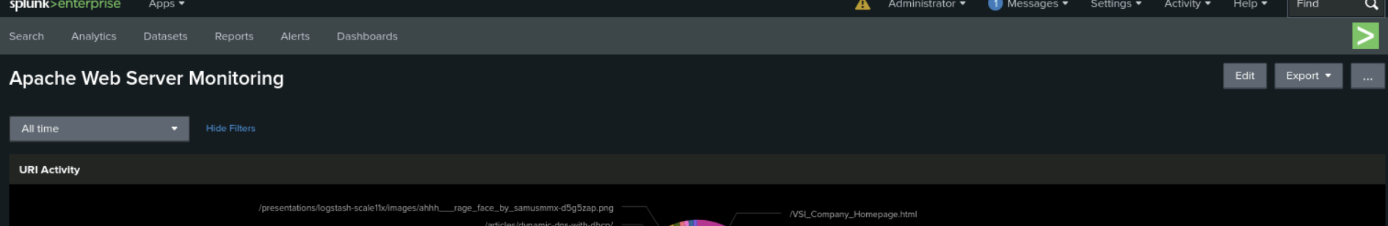

Day: 2 Monitoring and Analyzing Attacks

**Part 2: Analyze Windows Attack Logs**

Dashboard Setup

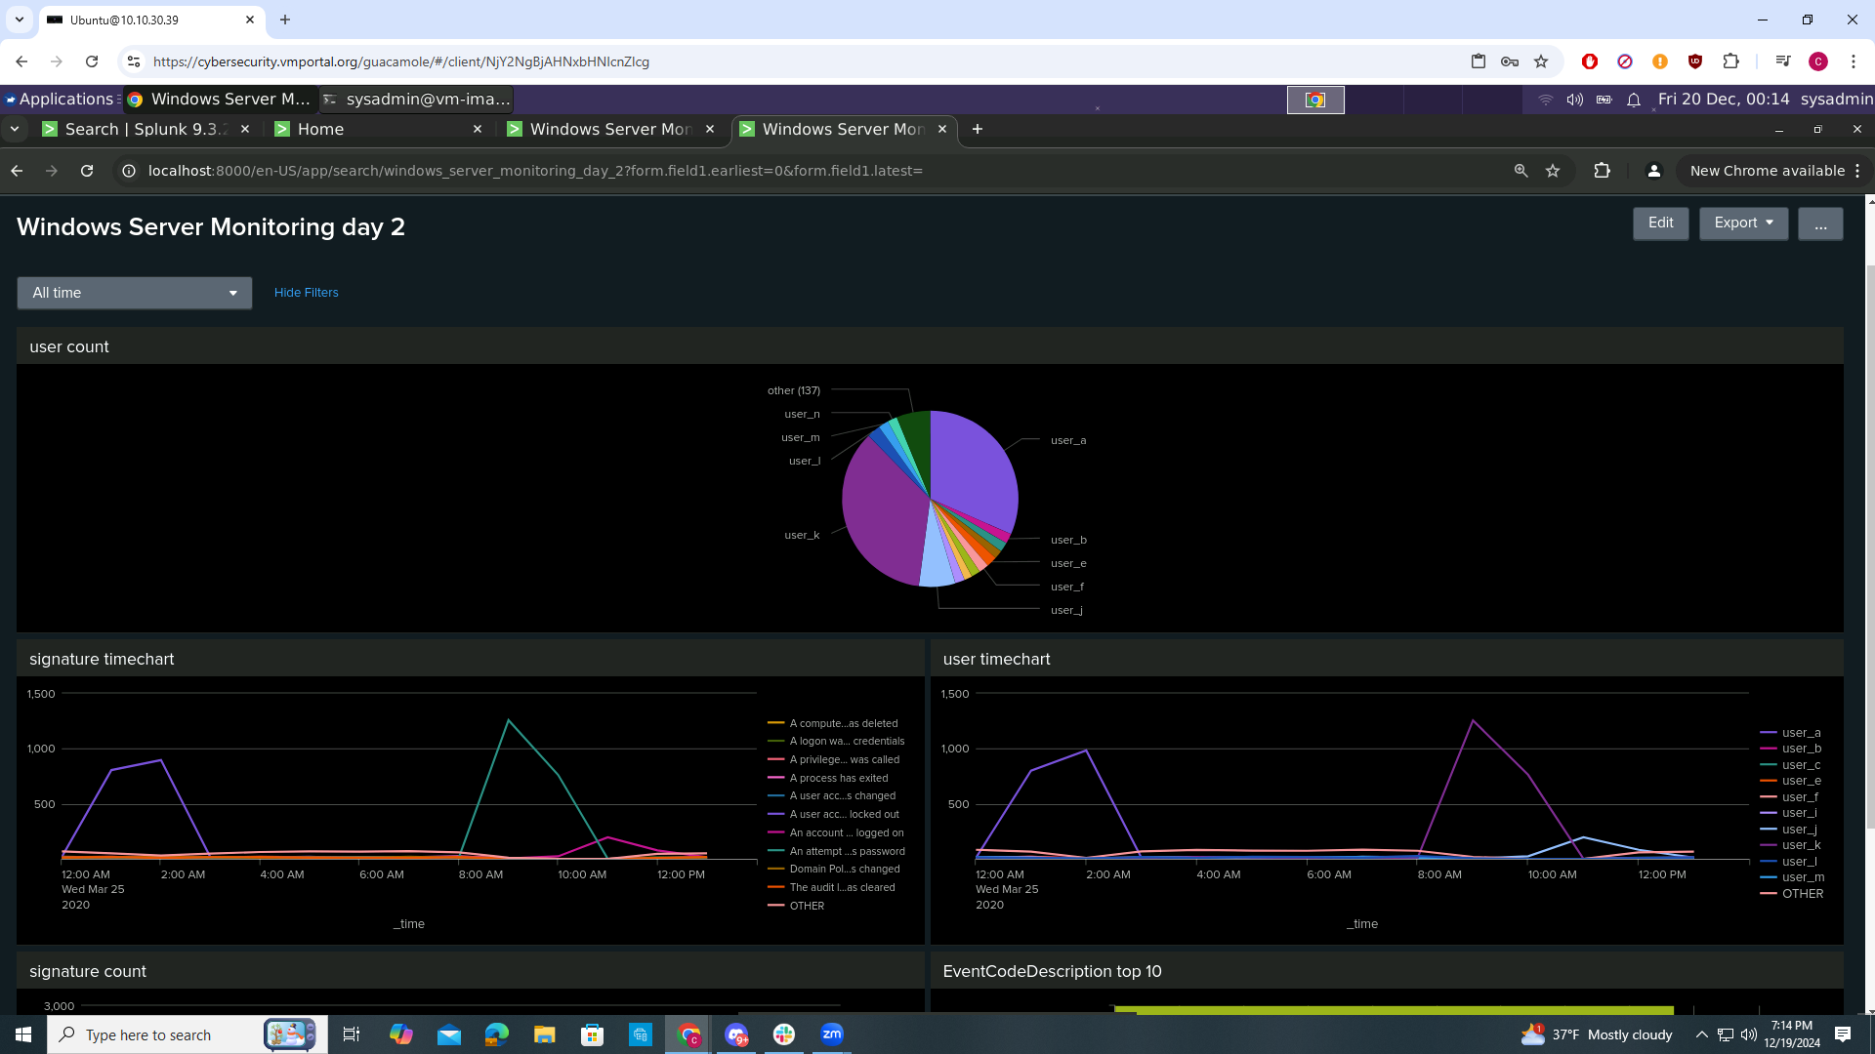

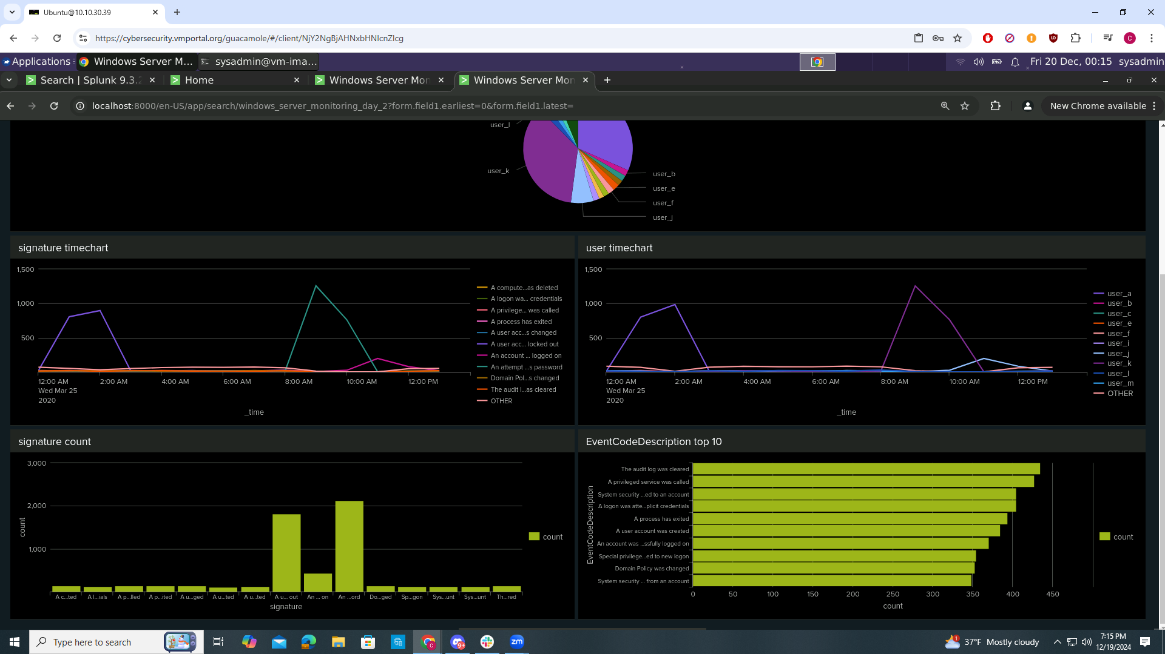

Dashboard Analysis for Time Chart of Signatures

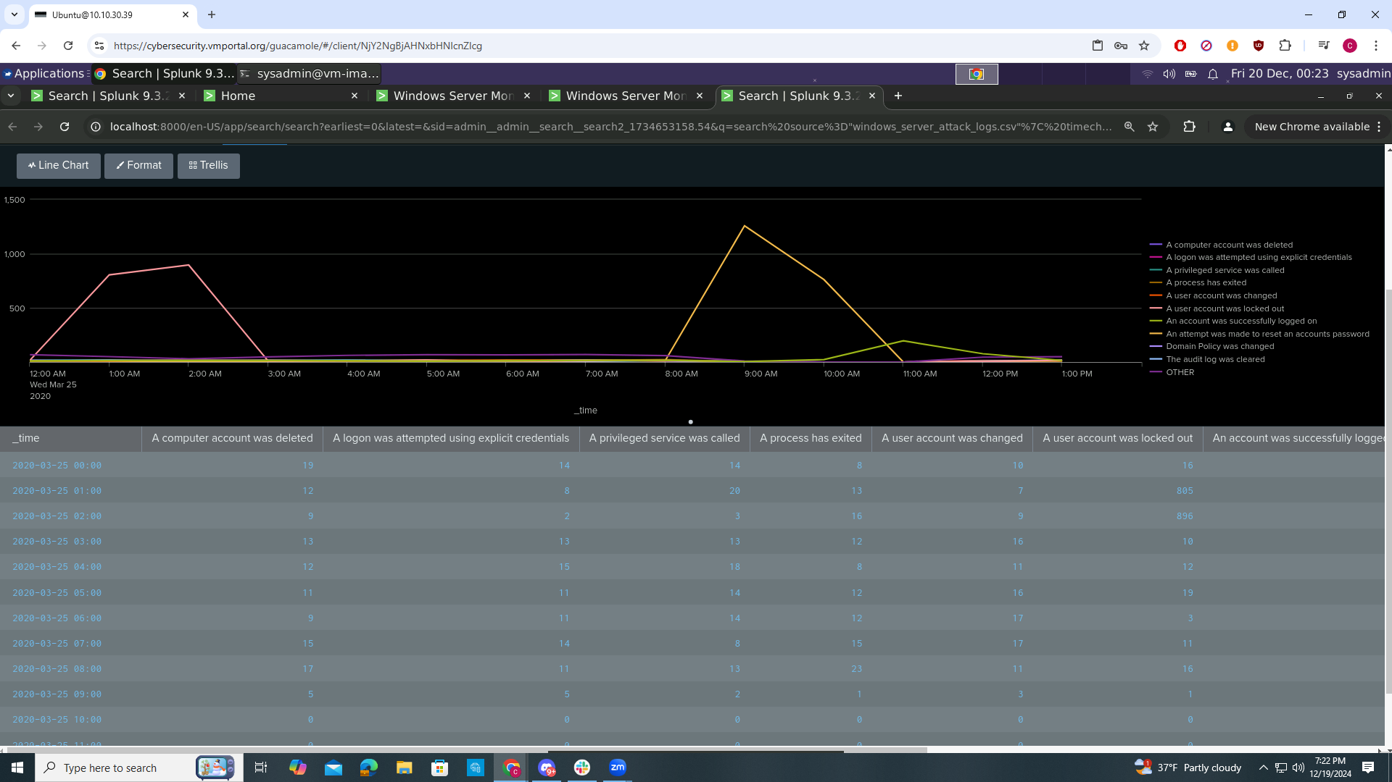

Does anything stand out as suspicious?

From 12:00-3:00 AM on Wed March 25 2020 the signature “a user account was locked out” had suspicious activity. Also from 8:00-11:00 AM on Wed March 25 2025 the signature “ an attempt was made to reset an accounts password” had suspicious activity.

What signatures stand out?

A user account was locked out

An attempt was made to reset an accounts password

What time did each signature’s suspicious activity begin and stop?

“A user account was locked out” begin at 12:00 AM stopped at 3:00 AM

“An attempt was made to reset an accounts password” begin at 8:00 AM stopped at 11:00 AM

What is the peak count of the different signatures?

“A user account was locked out” peak count was 896

“An attempt was made to reset an accounts password” peak count was 1258

Dashboard Analysis for Users

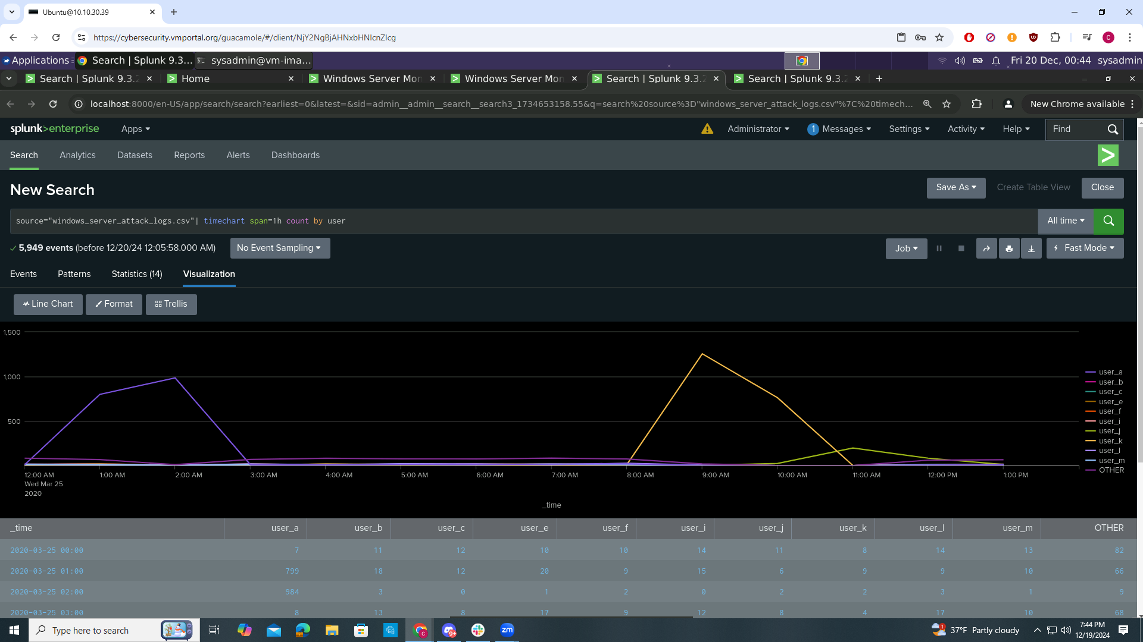

Does anything stand out as suspicious?

There was suspicious activity from user_a at 12:00-3:00 AM on Wed Mar 25 2020 and user_k from 8:00-11:00 AM

Which users stand out?

User_a and user_k

What time did each user’s suspicious activity begin and stop?

User_a activity begin at 12:00 AM and stopped at 3:00 AM on Wed Mar 25 2020

User_k activity begin at 8:00 AM and stopped at 11:00 AM on Wed Mar 25 2020

What is the peak count of the different users?

User_a peak count is 984

User_k peak count is 1256

Dashboard Analysis for Signatures with Bar, Graph, and Pie Charts

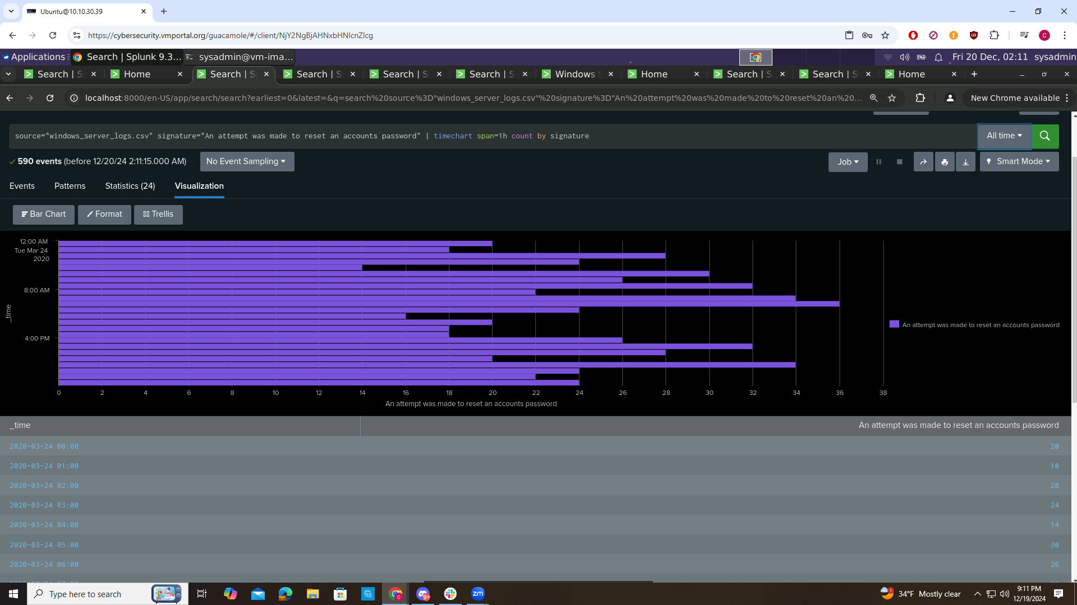

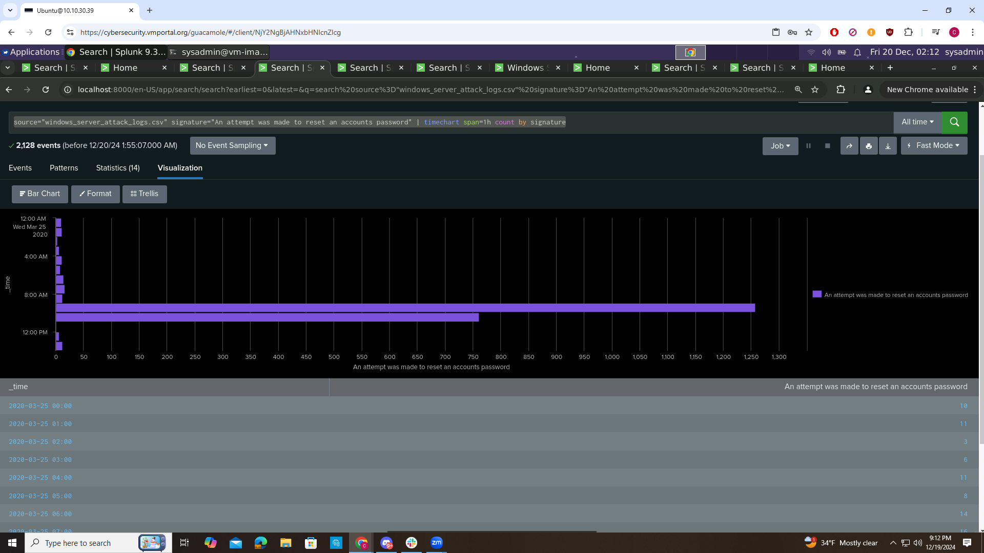

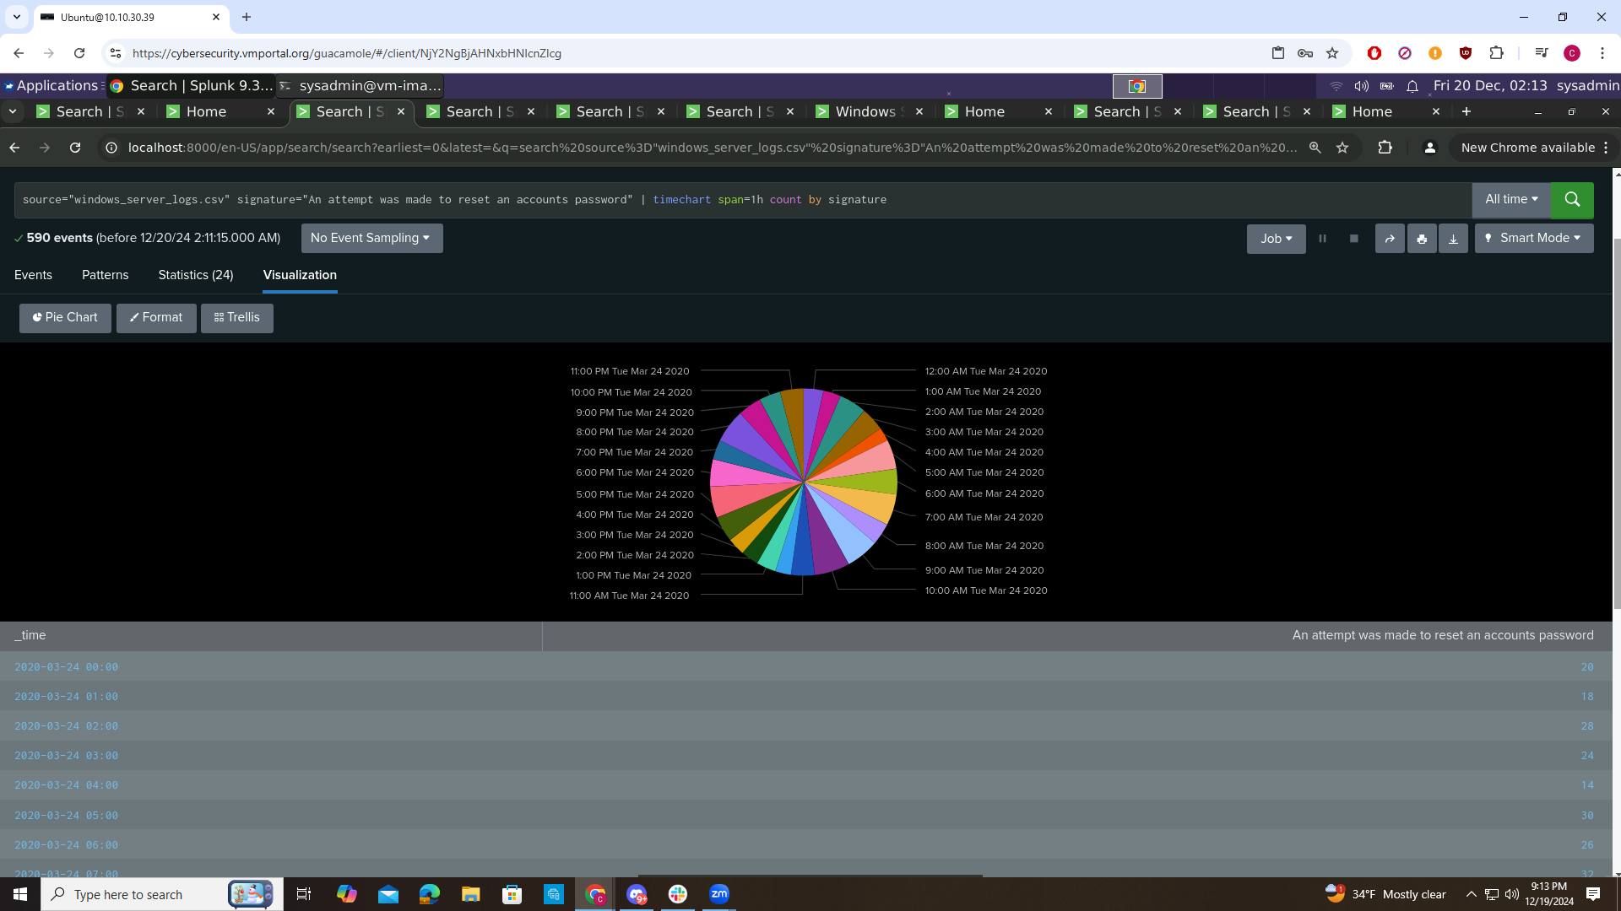

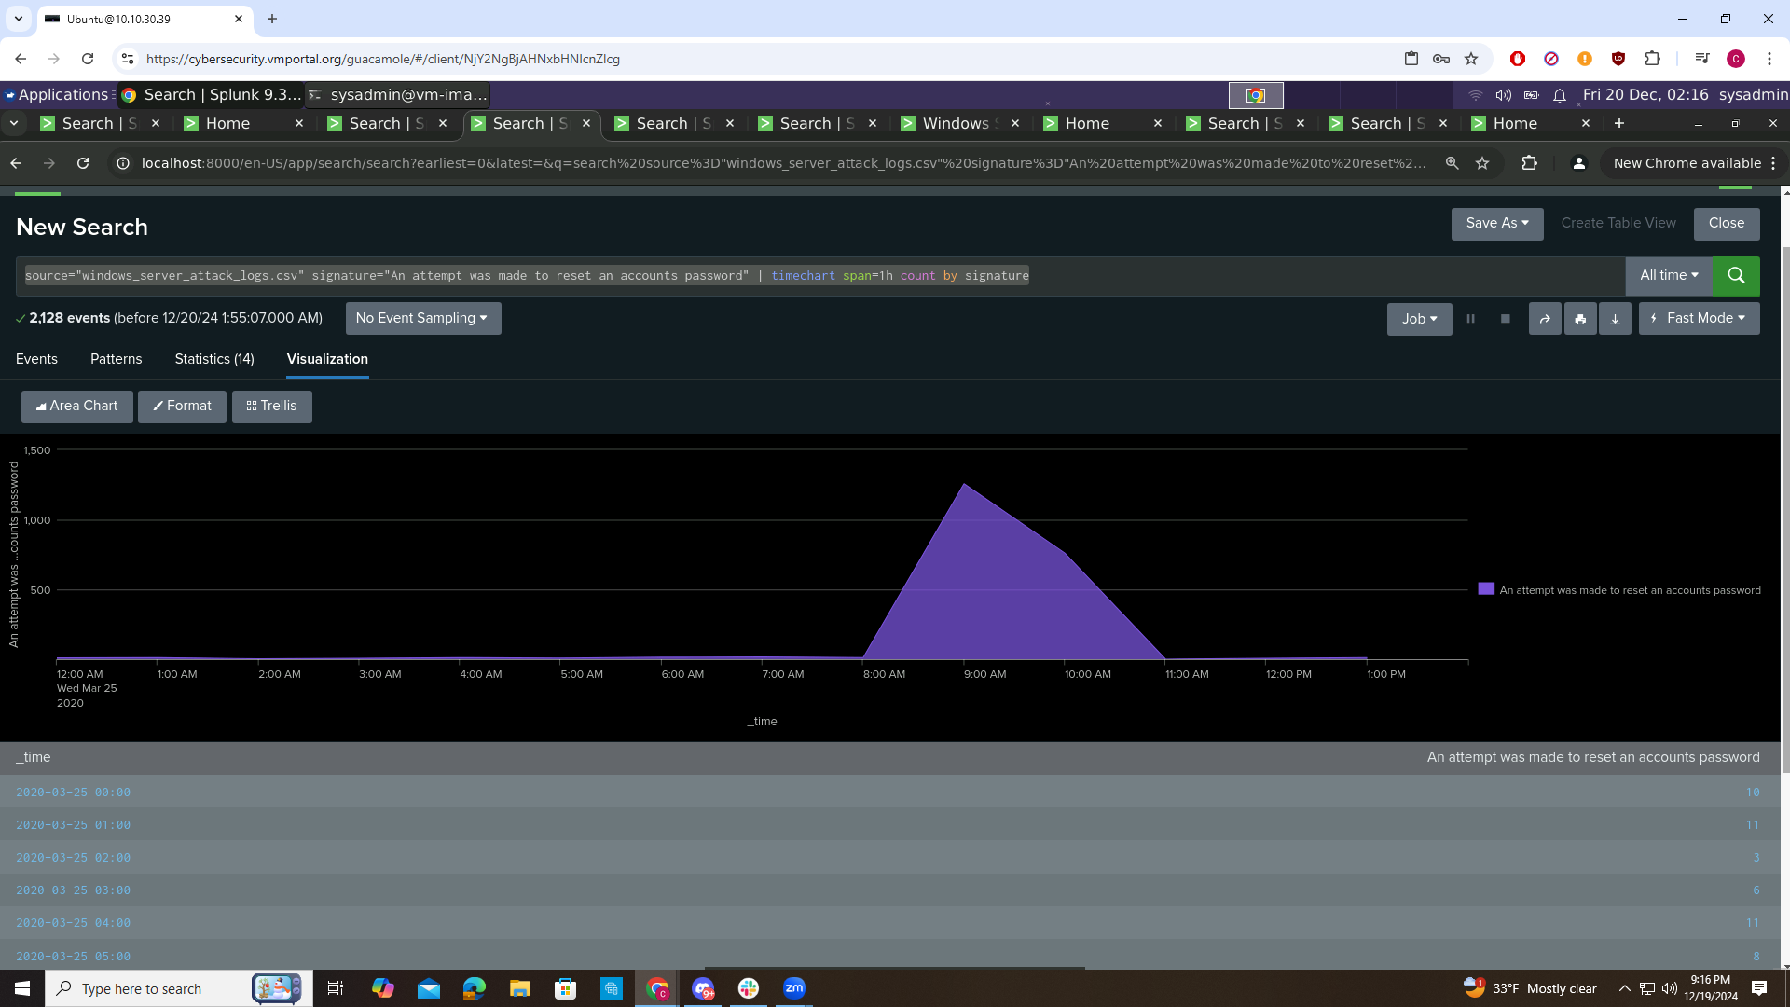

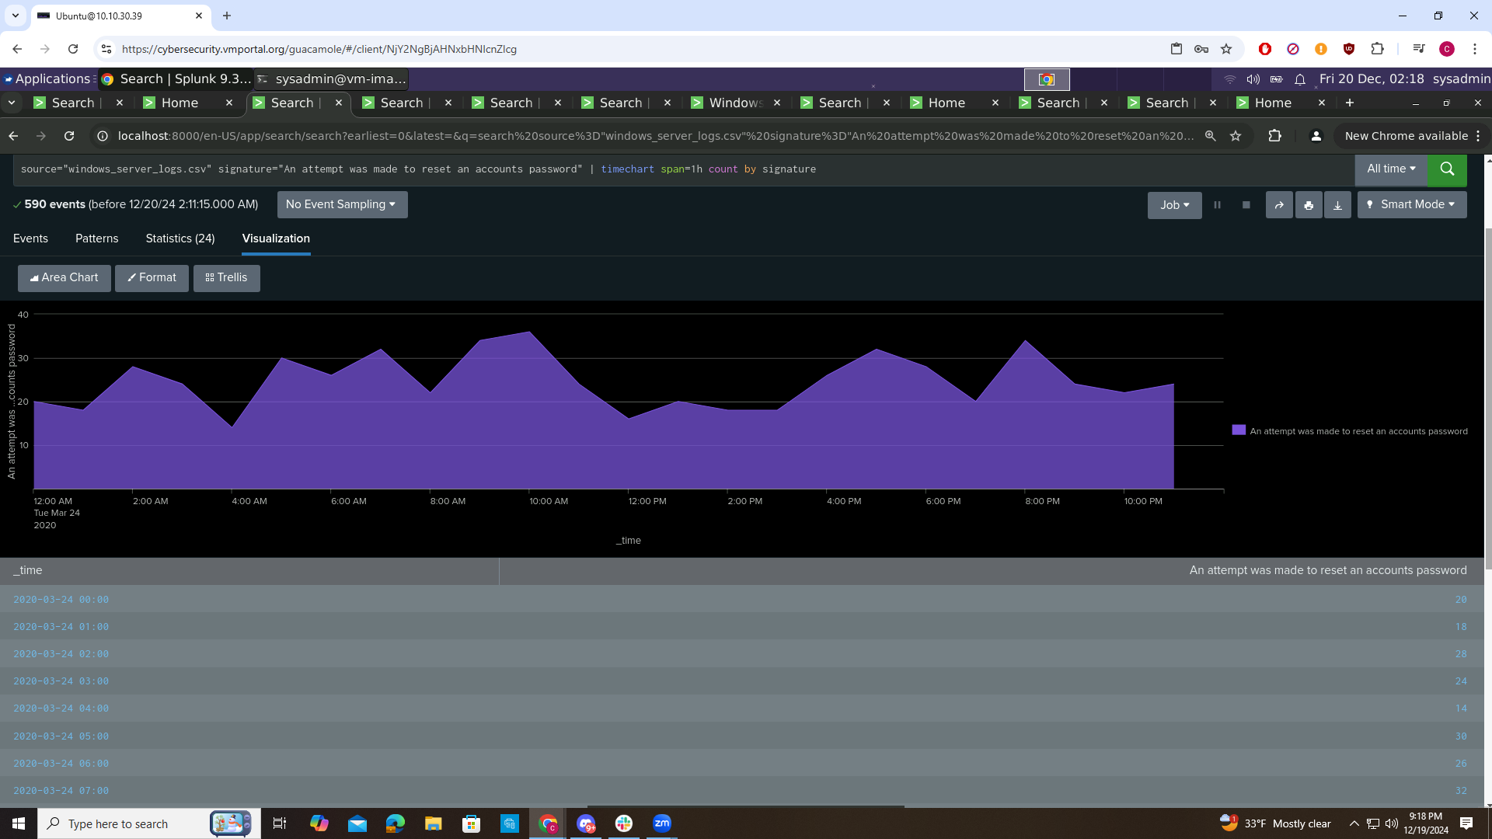

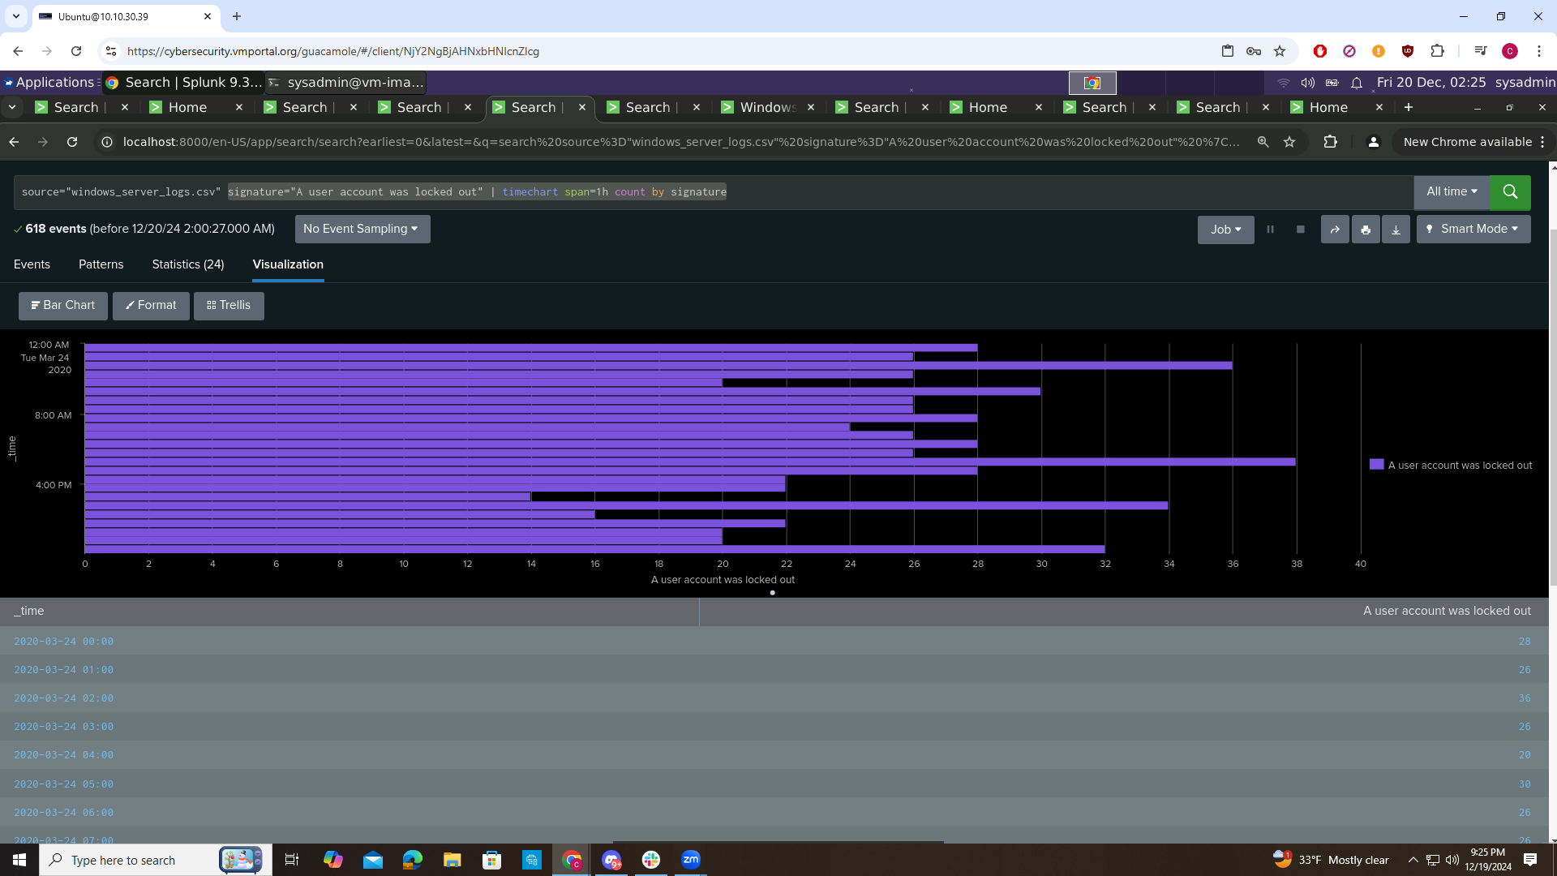

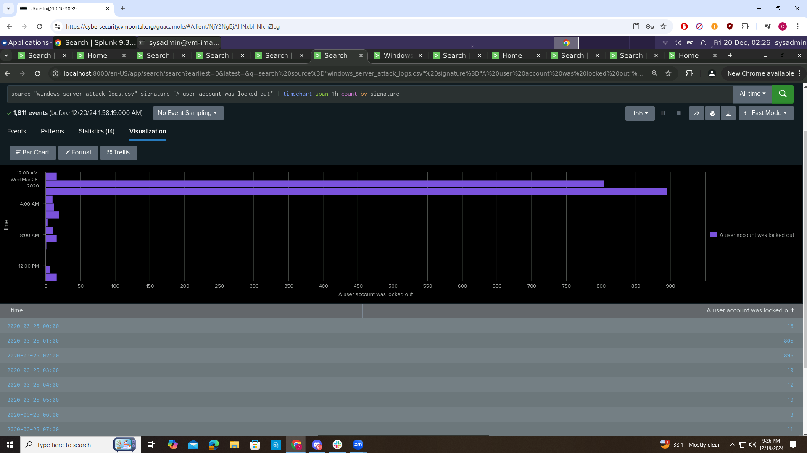

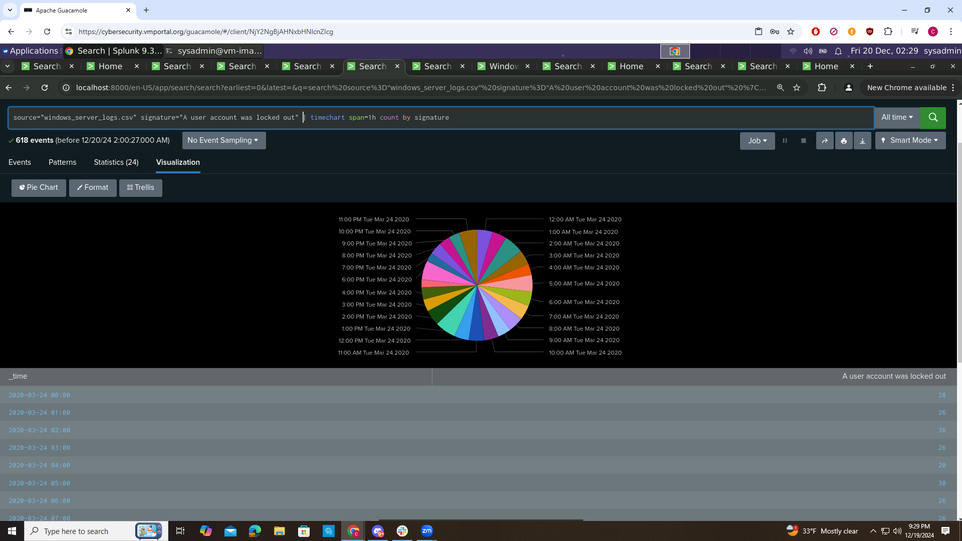

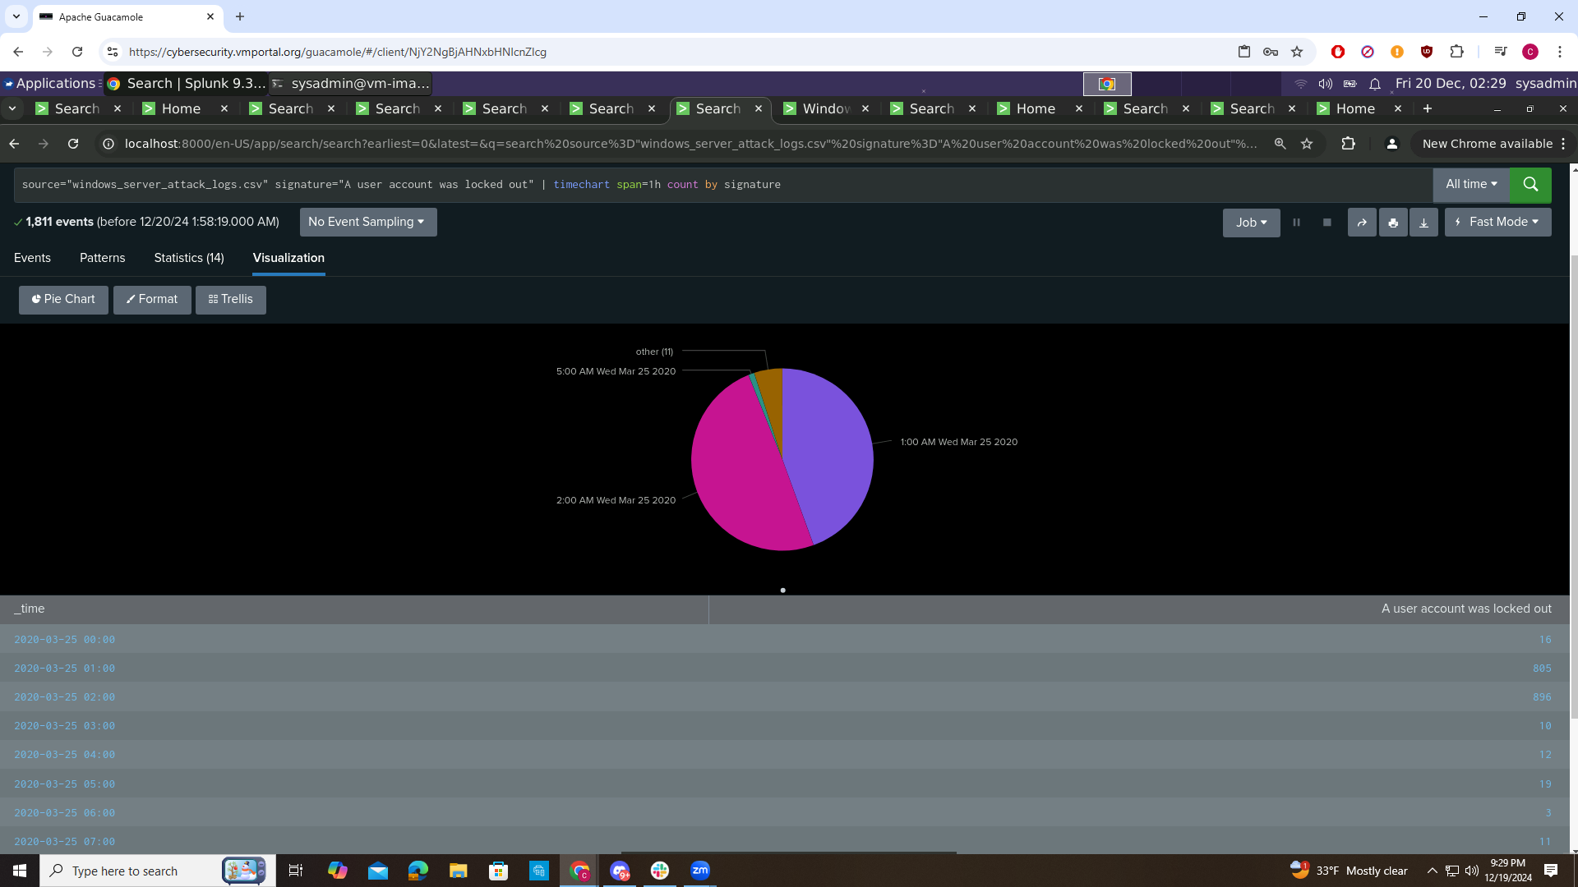

Does anything stand out as suspicious?

From 12:00-3:00 AM on Wed March 25 2020 the signature “a user account was locked out” had suspicious activity. Also from 8:00-11:00 AM on Wed March 25 2025 the signature “ an attempt was made to reset an accounts password” had suspicious activity.

Do the results match your findings from the time chart for signatures?

The data match for “a user account was locked out” and “an attempt was made to reset an account password” data match up with other information gathered from the dashboard

Dashboard Analysis for user with Bar, Graph, and Pie Charts

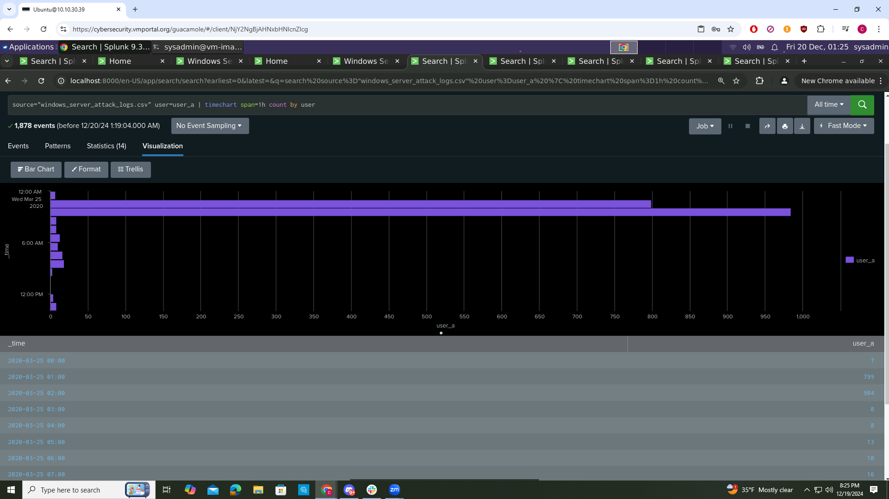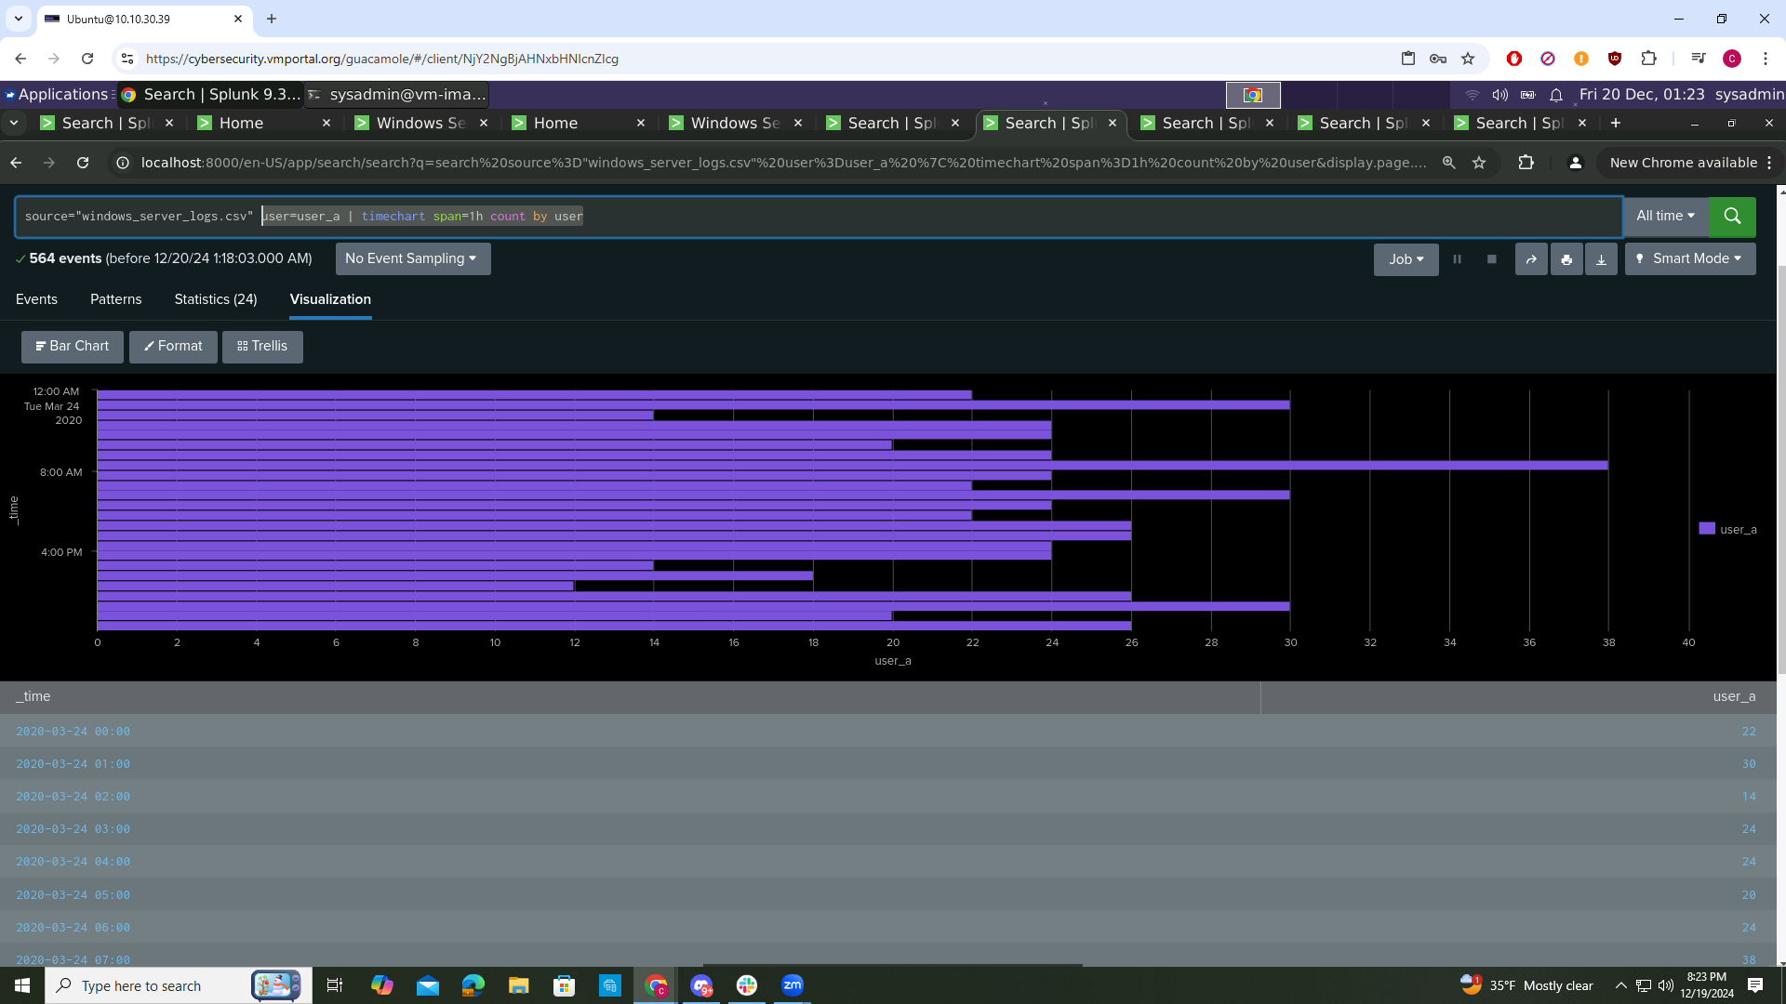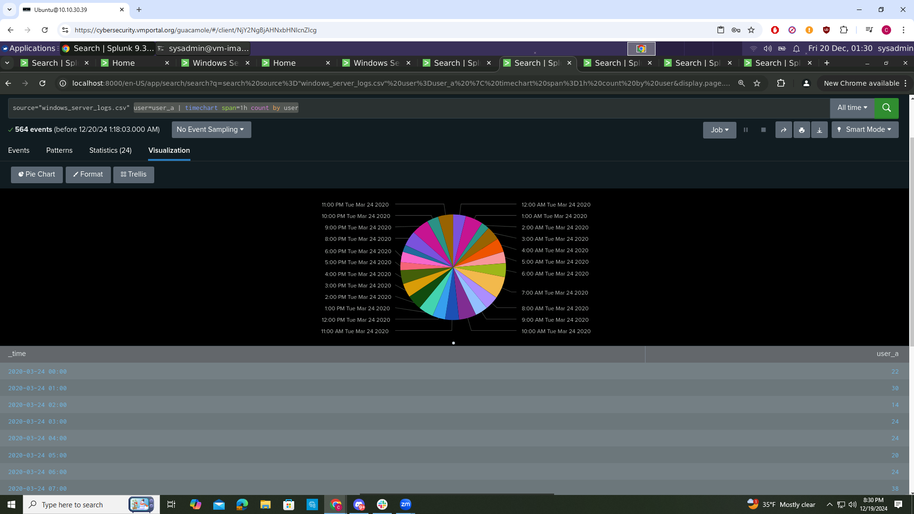

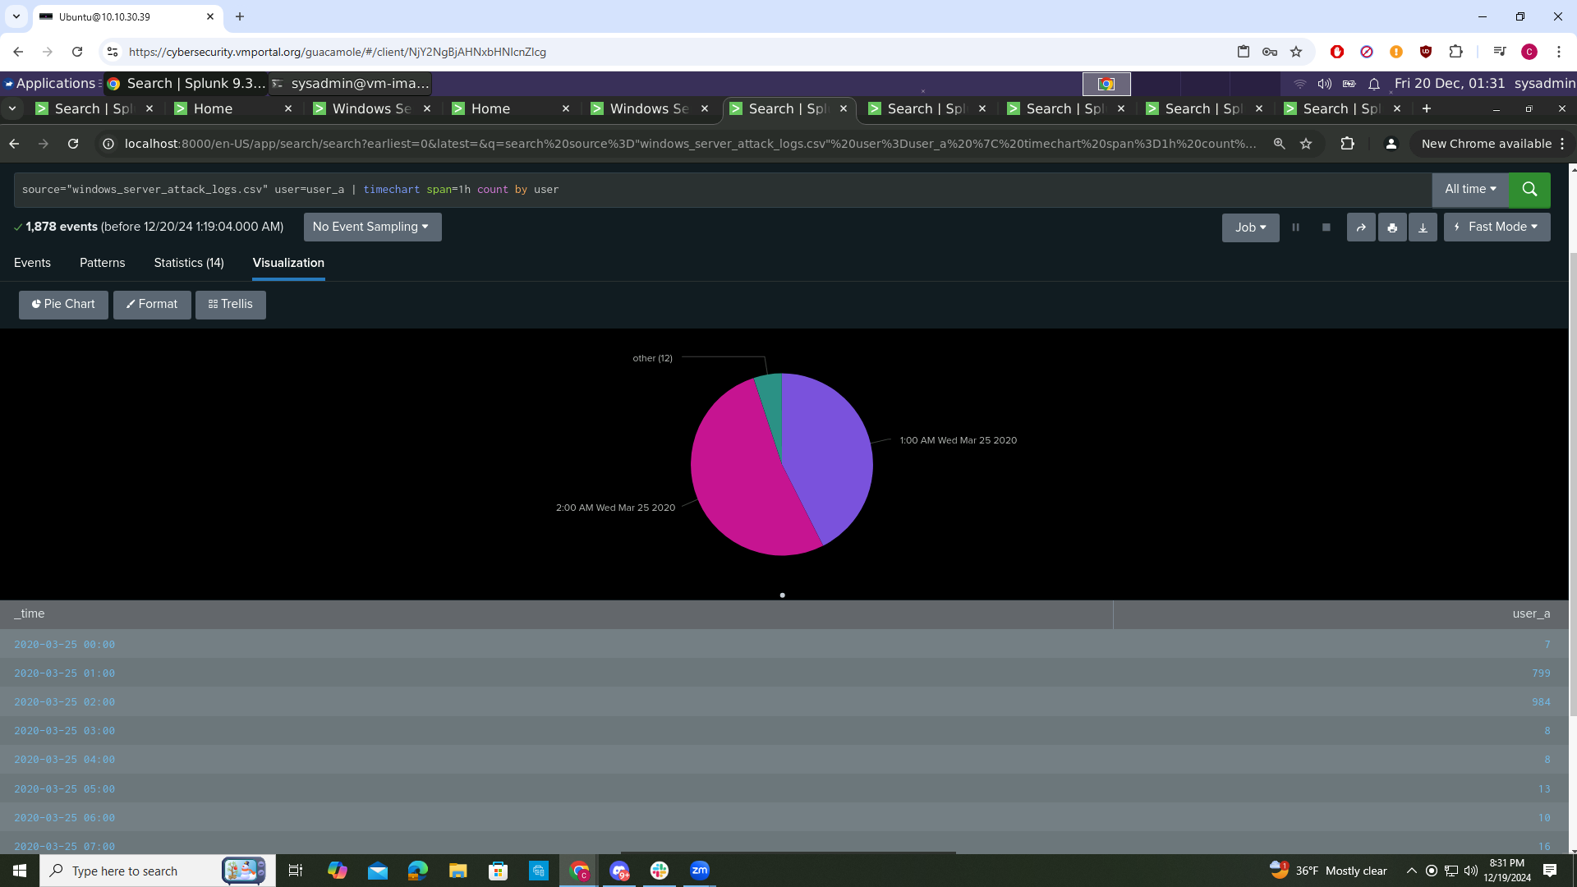

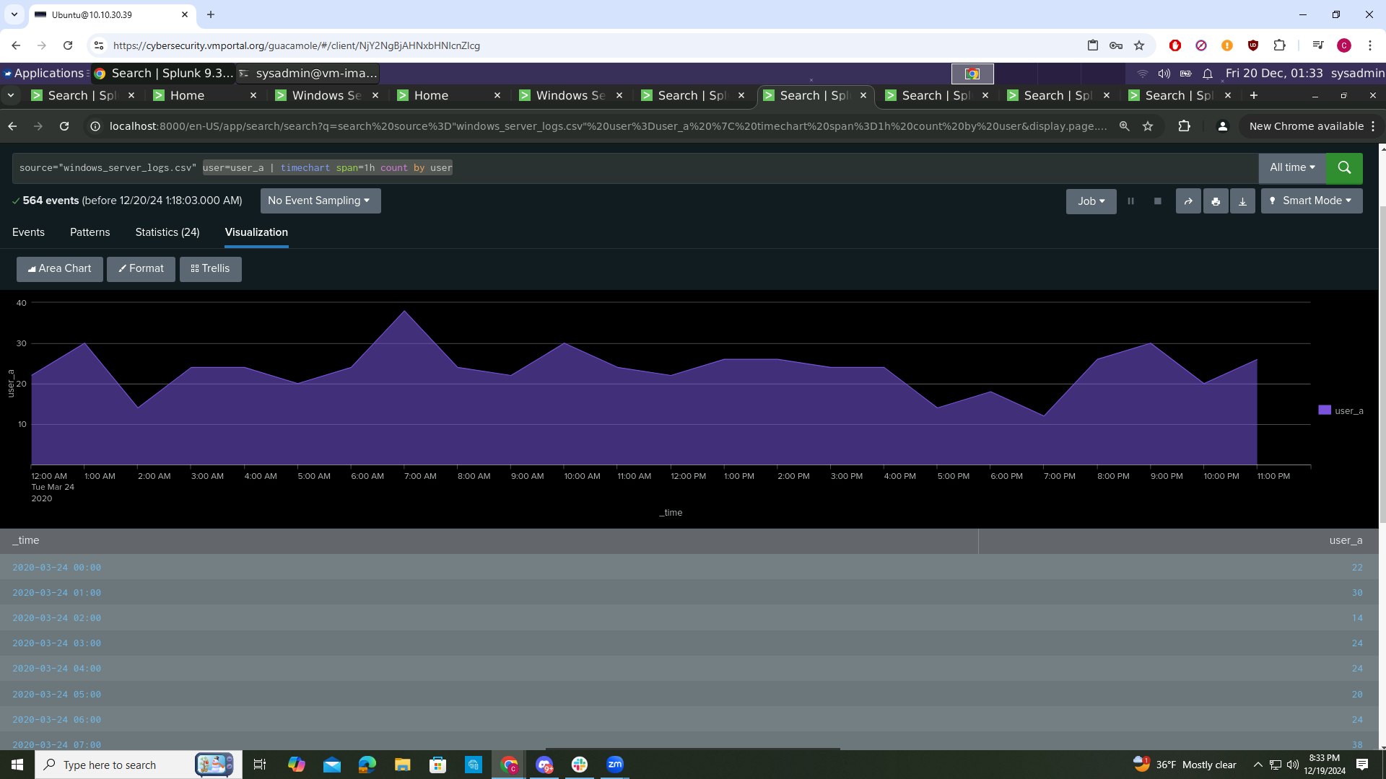

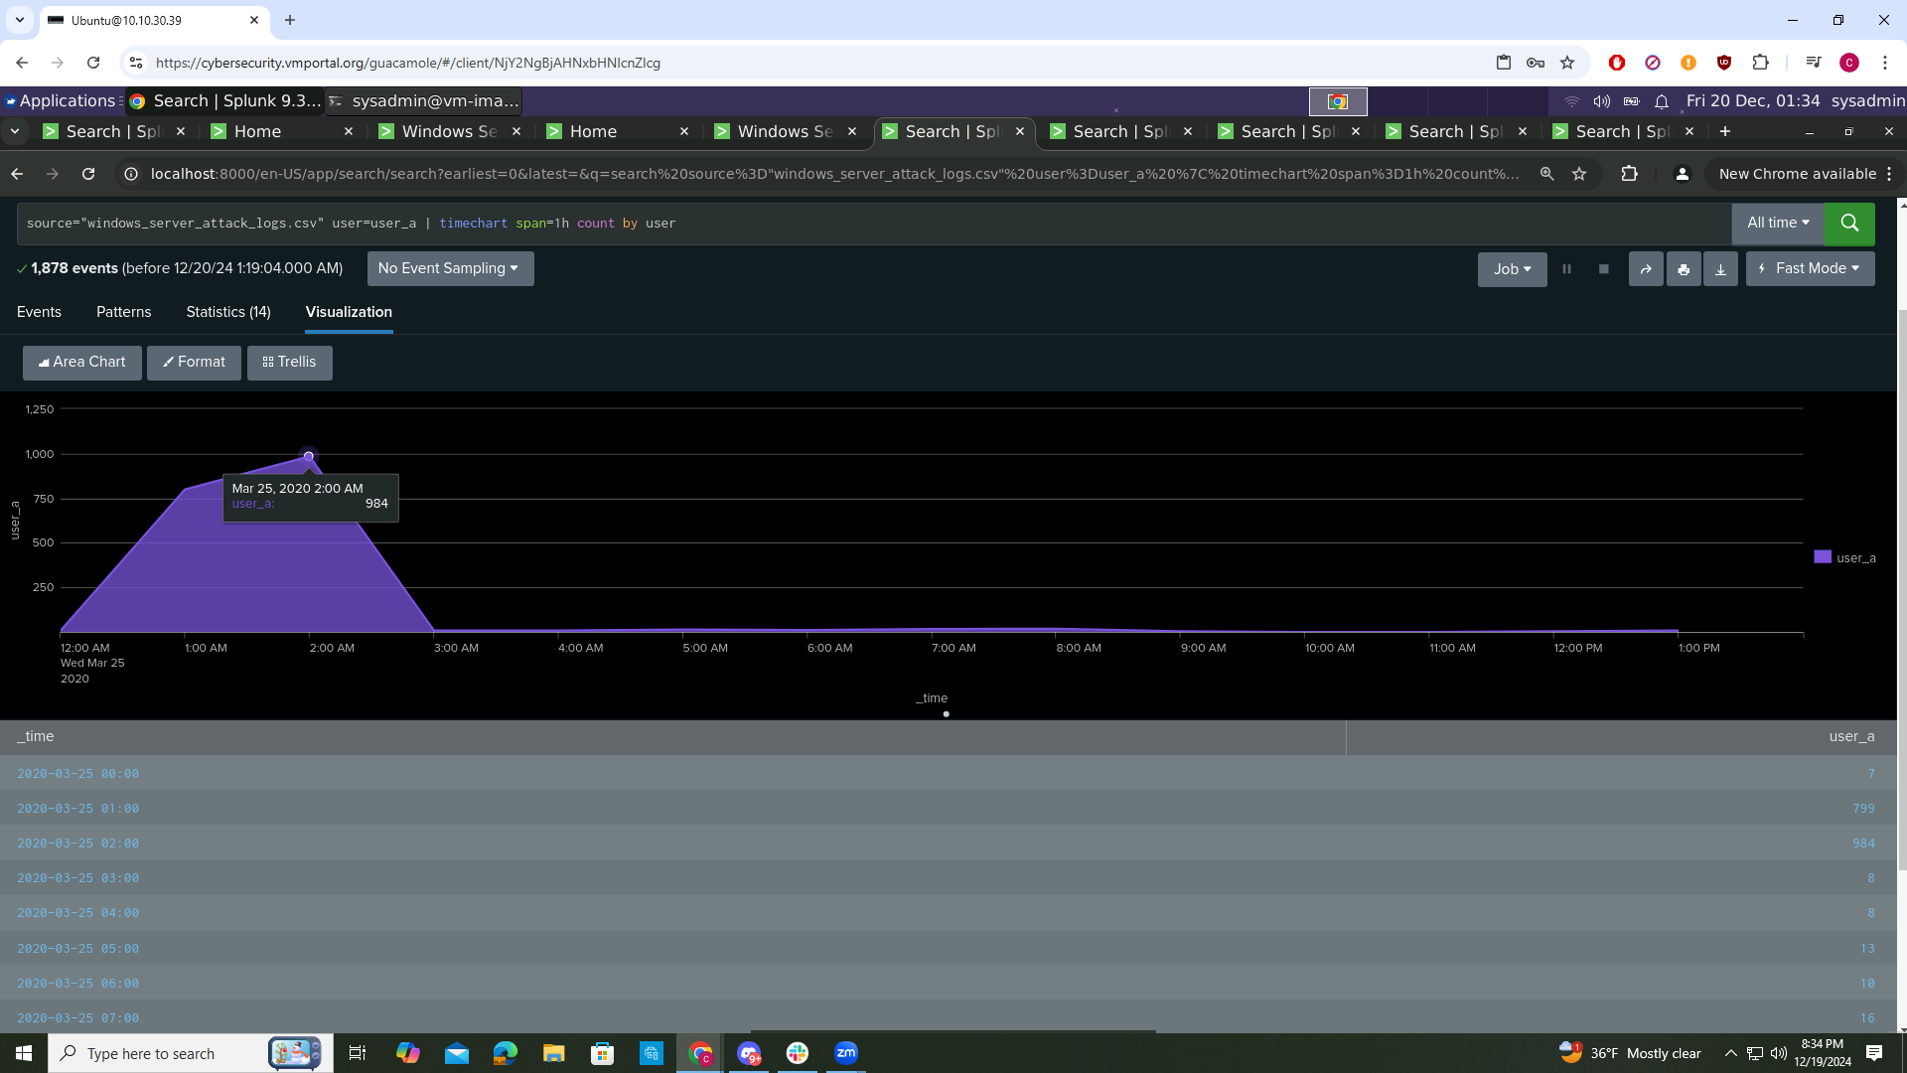

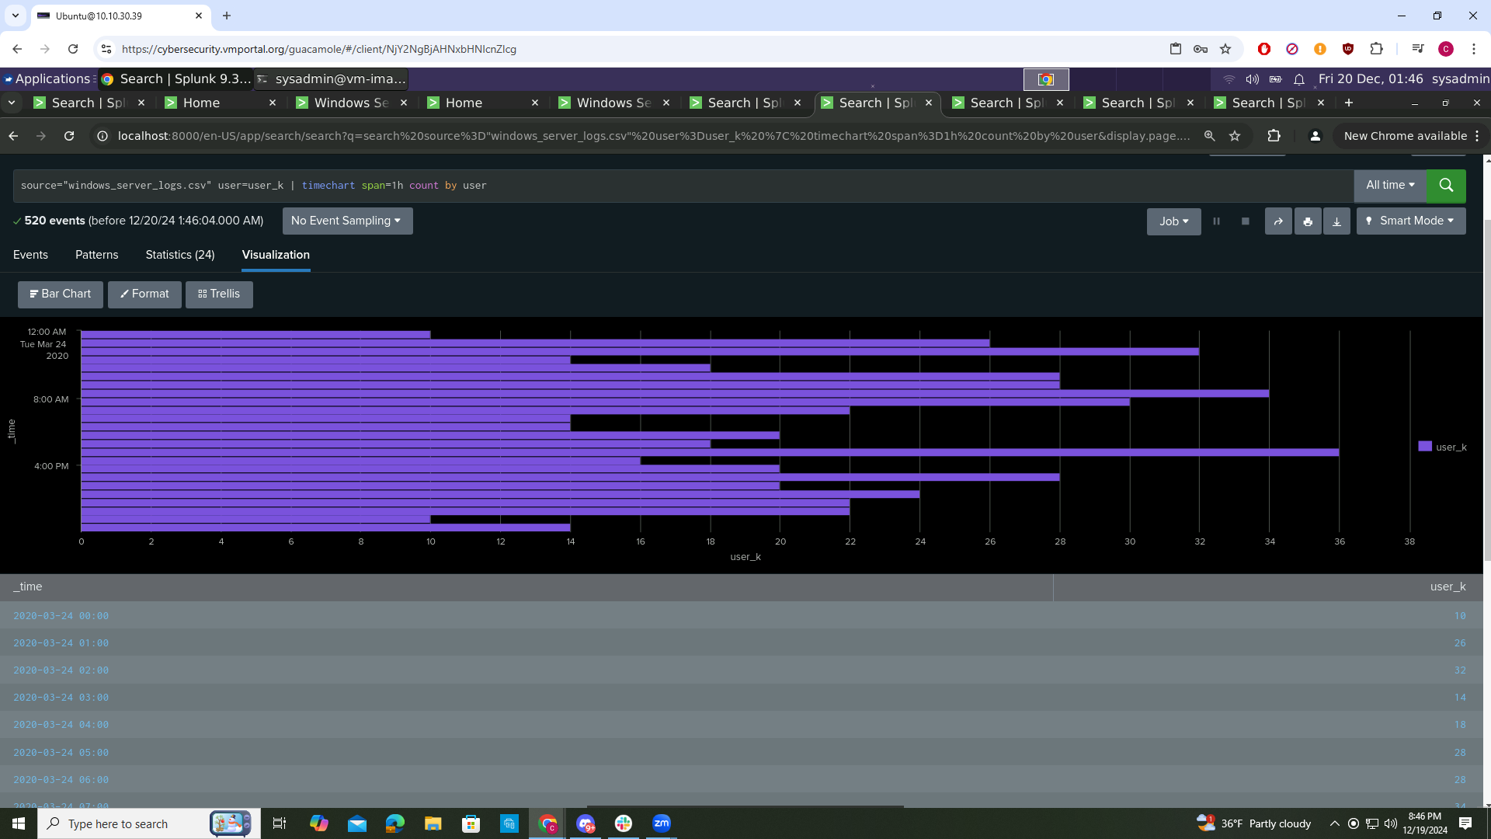

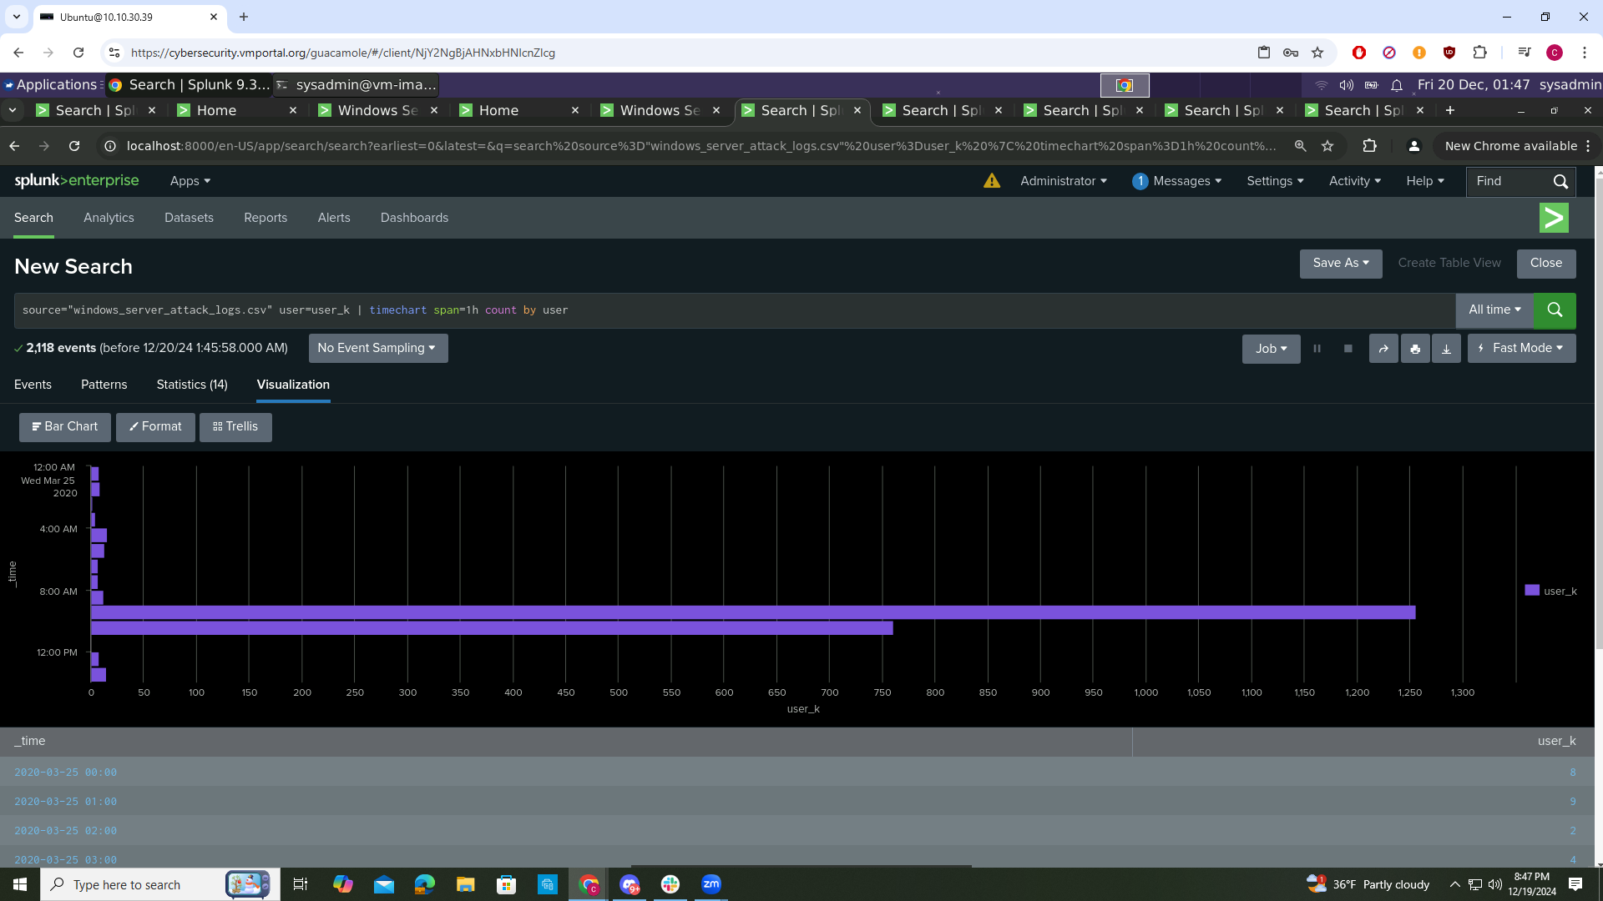

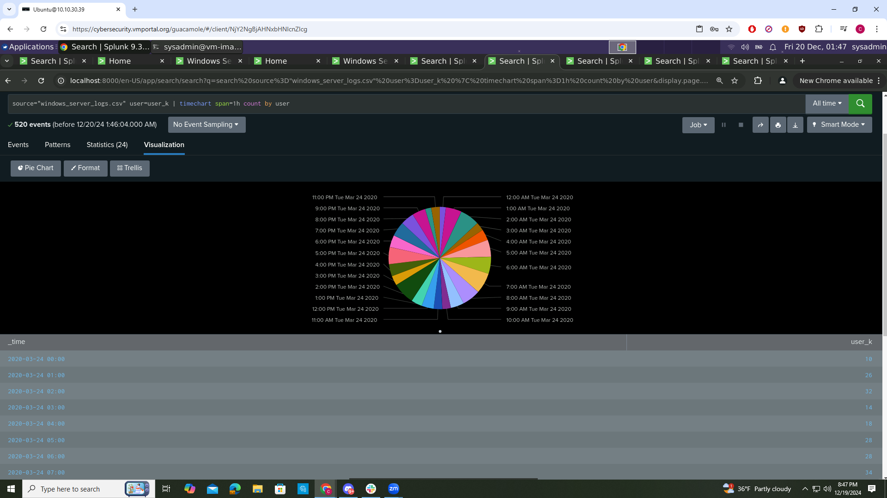

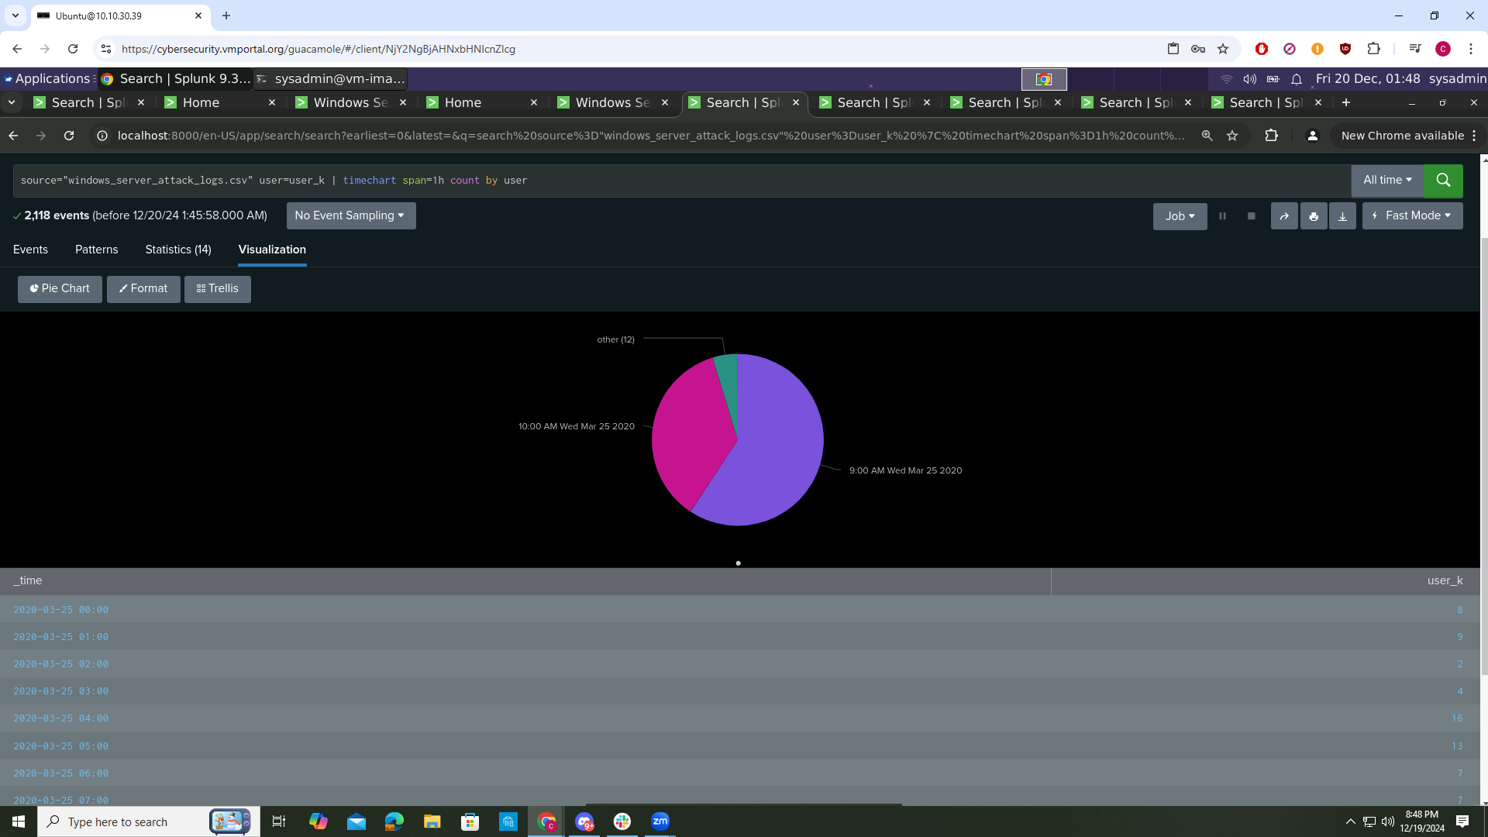

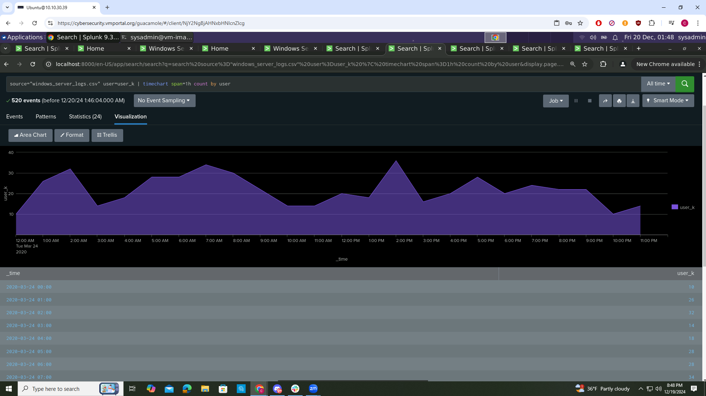

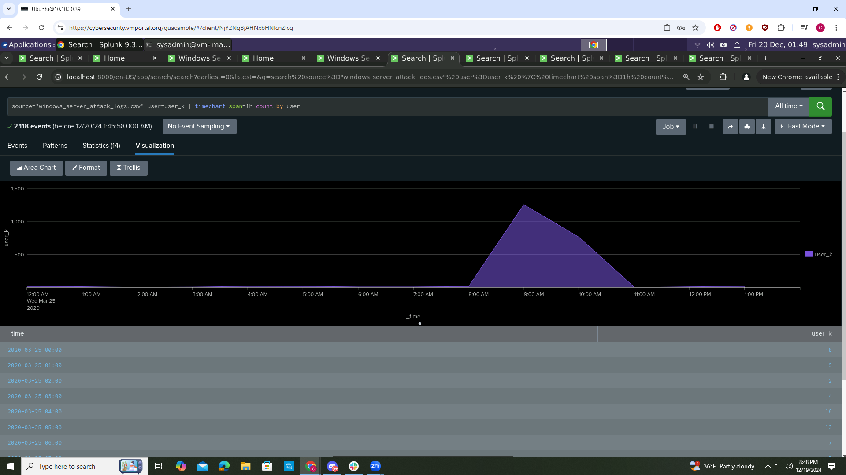

Does anything stand out as suspicious?

There was suspicious activity from user_a at 12:00-3:00 AM on Wed Mar 25 2020 and user_k from 8:00-11:00 AM

Do the results match your findings from the time chart for User?

Yes you can see the jump in activity of user_a and and user_k all round the same time in all of the charts

Dashboard Analysis for Users with Statistical Charts

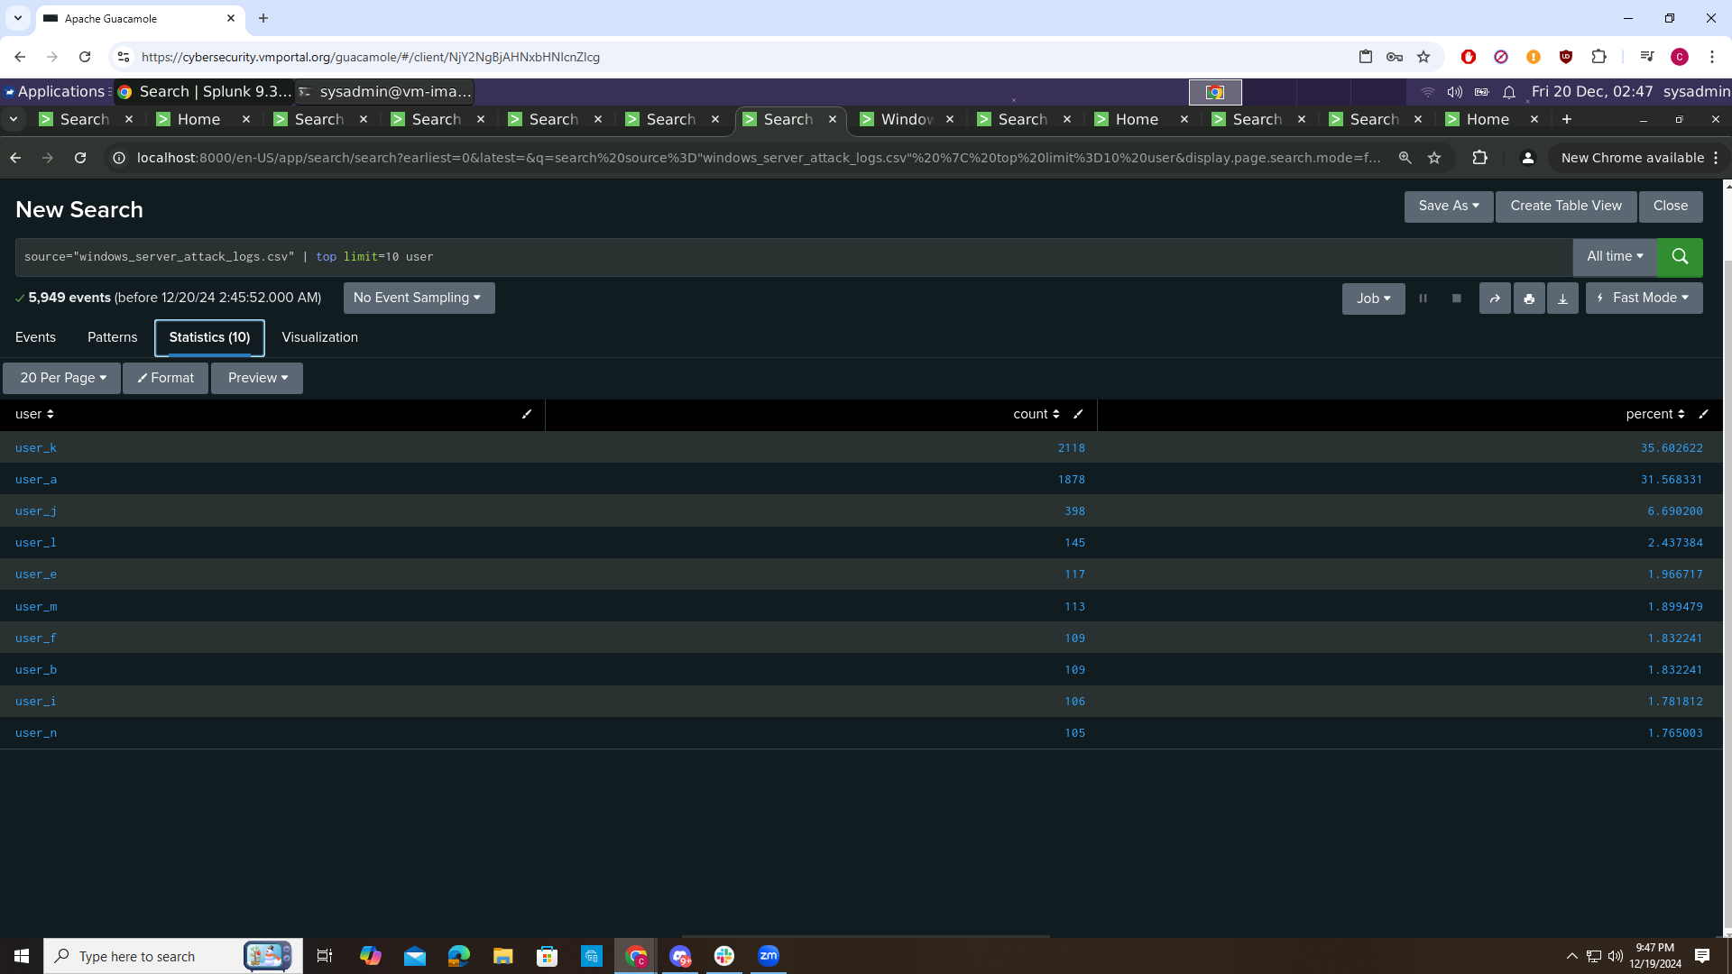

What are the advantages and disadvantages of using this report, compared to the other user panels that you created?

An advantage of using a statistical chart is you can see trends more quickly, good for tracking metrics over a period and can easily compare different metrics or data points over time. Disadvantages are that it can give you a summary, but they might not provide the full context of the data, and can oversimplify the data by focusing solely on aggregates and summaries, which may hide important nuances in the data. With the other panels you can visually see what the date looks like and detailed analysis of individual occurrences.

### **Part 4: Analyze Apache Attack Logs**

In this part, you will review the reports, alerts, and dashboards that you created on Day 1 and analyze the results. To do so, complete the following steps:

#### **Report Analysis for Methods**

1. Access the “Reports” tab, and select “Yours” to view the reports that you created on Day 1.
2. Select the report that analyzes the different HTTP methods.
3. Select “Edit” > “Open in Search.”
4. Take note of the percent and count of the various methods.
5. Change the source from source="apache_logs.txt" to source="apache_attack_logs.txt".
6. Select “Save.”
7. Review the updated results, and answer the following questions in the review document:

○ Did you detect any suspicious changes in HTTP methods? If so, which one?

○ What is that method used for?

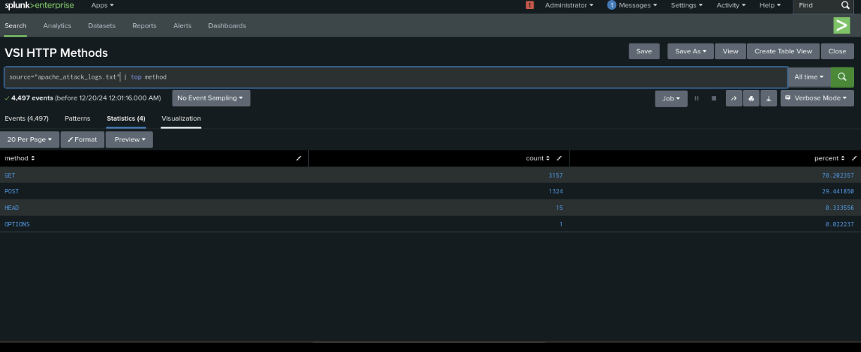

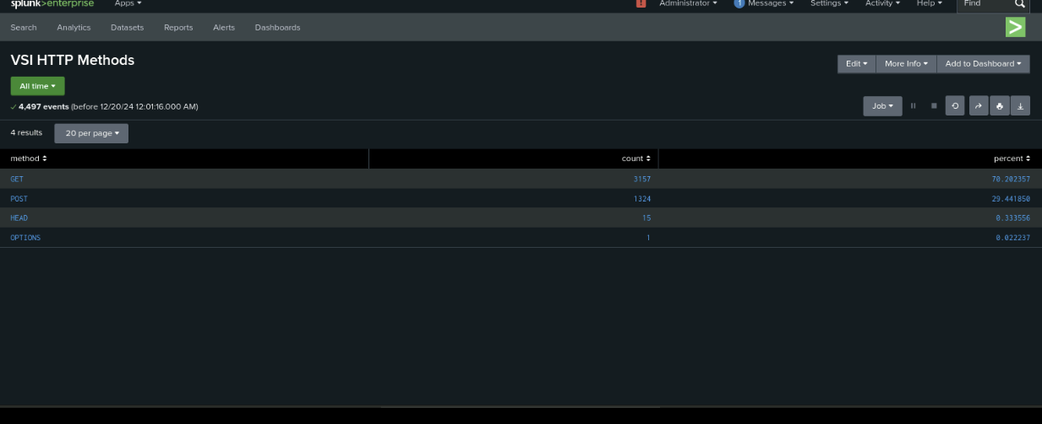

#### **Report Analysis for Referrer Domains**

1. Access the “Reports” tab, and select “Yours” to view the reports that you created on Day 1.
2. Select the report that analyzes the different referrer domains.
3. Select “Edit” > “Open in Search.”
4. Take note of the different referrer domains.
5. Change the source from source="apache_logs.txt" to source="apache_attack_logs.txt".
6. Select “Save.”
7. Review the updated results, and answer the following question in the review document:

○ Did you detect any suspicious changes in referrer domains?

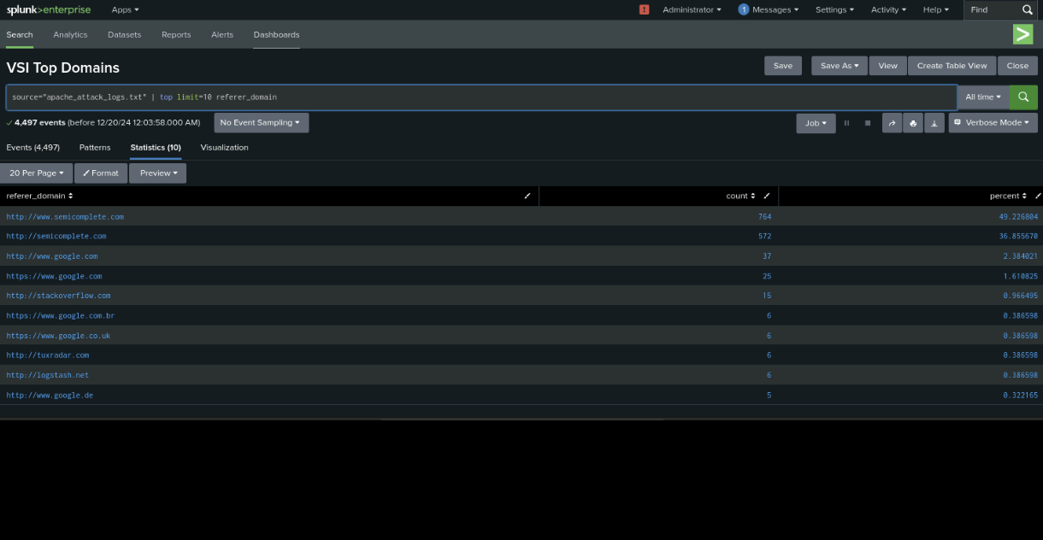 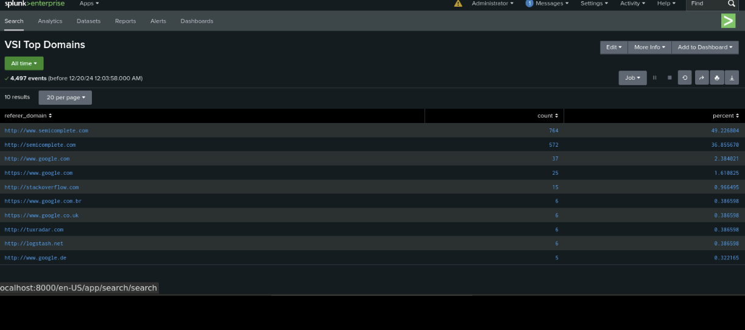

#### **Report Analysis for HTTP Response Codes**

1. Access the “Reports” tab, and select “Yours” to view the reports that you created on Day 1.
2. Select the report that analyzes the different HTTP response codes.
3. Select “Edit” > “Open in Search.”
4. Take note of the different HTTP response codes.
5. Change the source from source=apache_logs.txt to source="apache_attack_logs.txt.
6. Select “Save.”
7. Review the updated results, and answer the following question in the review document:

○ Did you detect any suspicious changes in HTTP response codes?

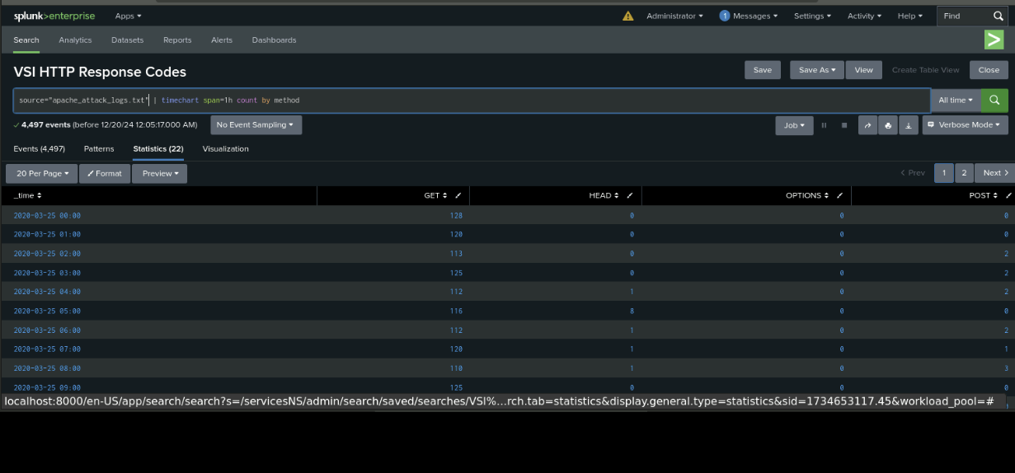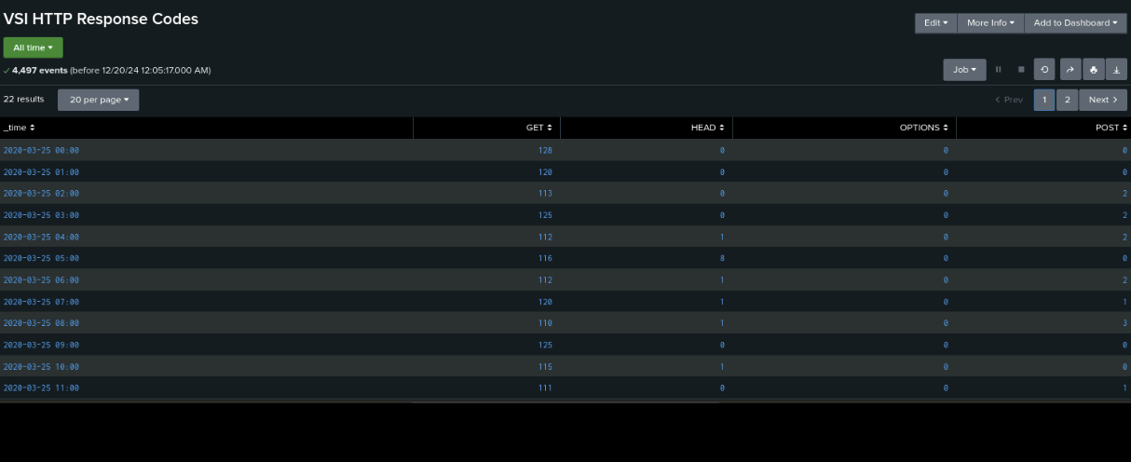

Now, you will review the alerts that you created on Day 1 and analyze the results.

#### **Alert Analysis for International Activity**

1. Access the “Alerts” tab, and select “Yours” to view the alerts that you created on Day 1.
2. Select the alert for suspicious volume of international activity.
3. Select “Open in Search.”
4. Change the source from source=apache_logs.txt to source="apache_attack_logs.txt.
5. Review the updated results, and answer the following questions in the review document:

○ Did you detect a suspicious volume of international activity?

○ If so, what was the count of events in the hour(s) it occurred?

○ Would your alert be triggered for this activity?

○ After reviewing, would you change the threshold you previously selected?

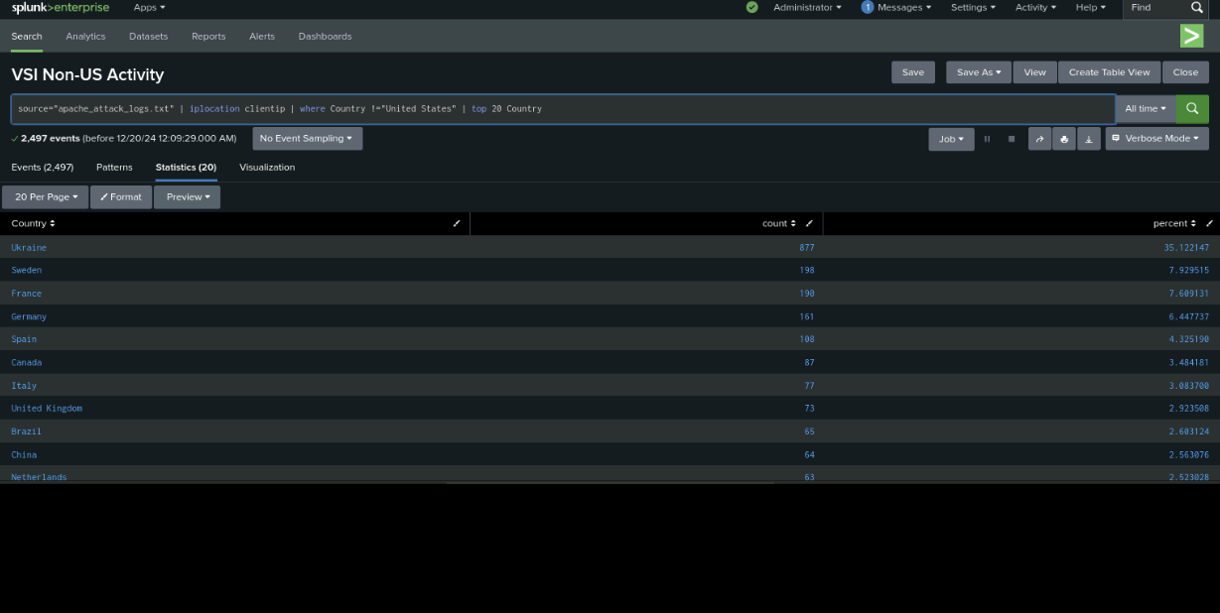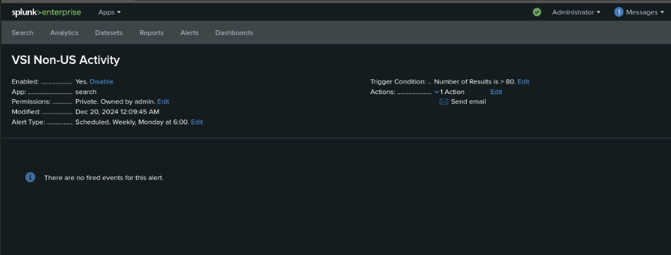

#### **Alert Analysis for HTTP POST Activity**

1. Access the “Alerts” tab, and select “Yours” to view the alerts that you created on Day 1.
2. Select the alert for suspicious volume of HTTP POST activity.
3. Select “Open in Search.”
4. Change the source from source="apache_logs.txt" to source="apache_attack_logs.txt".
5. Review the updated results, and answer the following questions in the review document:

○ Did you detect any suspicious volume of HTTP POST activity?

○ If so, what was the count of events in the hour(s) it occurred?

○ When did it occur?

○ After reviewing, would you change the threshold that you previously selected?

Now, you will set up a dashboard and analyze the results.

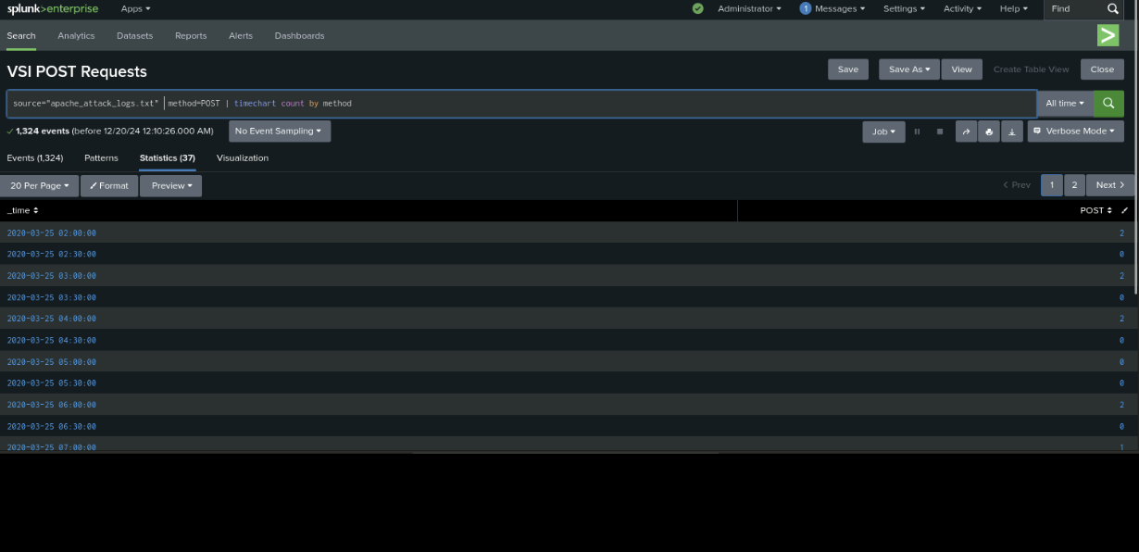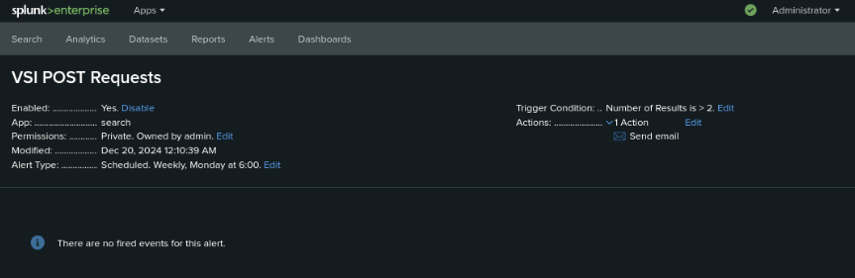

#### **Dashboard Setup**

1. Access the Apache Web Server Monitoring dashboard.
2. Select “Edit.”
3. For each panel that you created, access the panel and complete the following steps:

○ Select “Edit Search.”

○ Change the source from source="apache_logs.txt" to source="apache_attack_logs.txt".

○ Select “Apply.”

1. Save the whole dashboard.
2. Change the time on the whole dashboard to “All Time.”

#### **Dashboard Analysis for Time Chart of HTTP Methods**

Analyze your new dashboard results, and answer the following questions in the review document:

● Does anything stand out as suspicious?

● Which method seems to be used in the attack?

● At what times did the attack start and stop?

● What is the peak count of the top method during the attack?

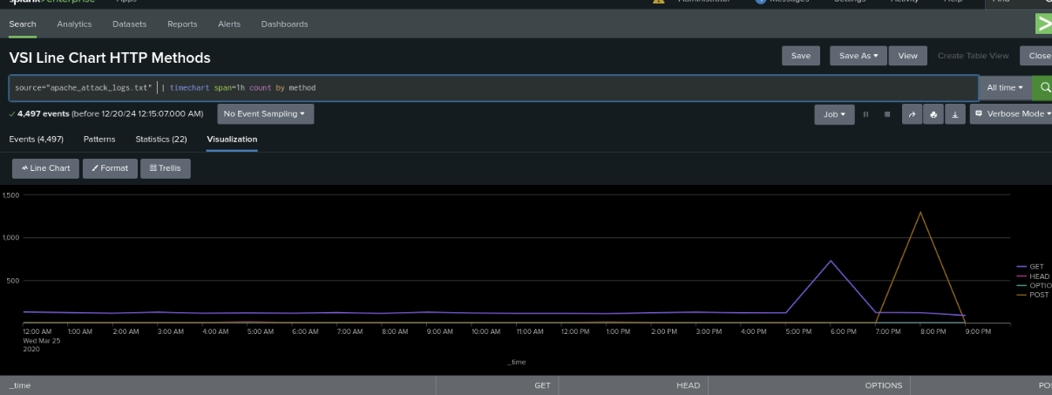

#### **Dashboard Analysis for Cluster Map**

Analyze your new cluster map results, and answer the following questions in the review document:

● Does anything stand out as suspicious?

● Which new location (city, country) on the map has a high volume of activity?

○ **Hint:** Zoom in on the map.

● What is the count of that city?

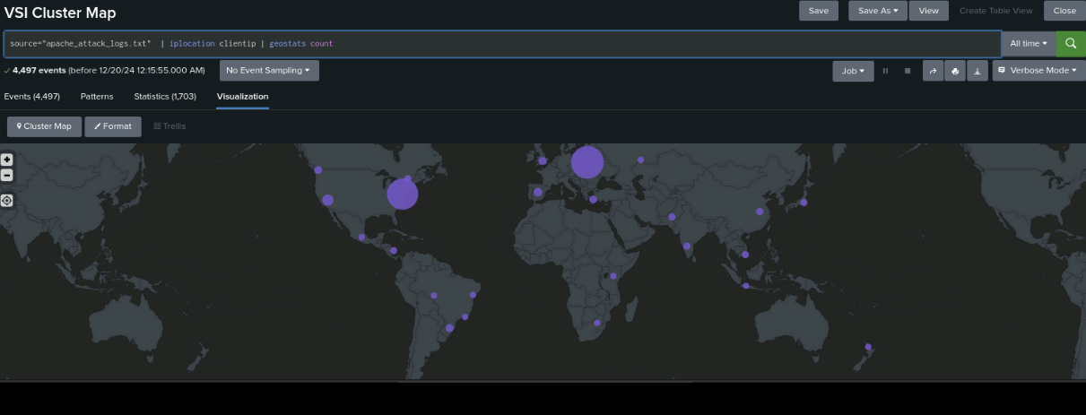

#### **Dashboard Analysis for URI Data**

Analyze your dashboard panel of the URI data, and answer the following questions in the review document:

● Does anything stand out as suspicious?

● What URI is hit the most?

● Based on the URI being accessed, what could the attacker potentially be doing?

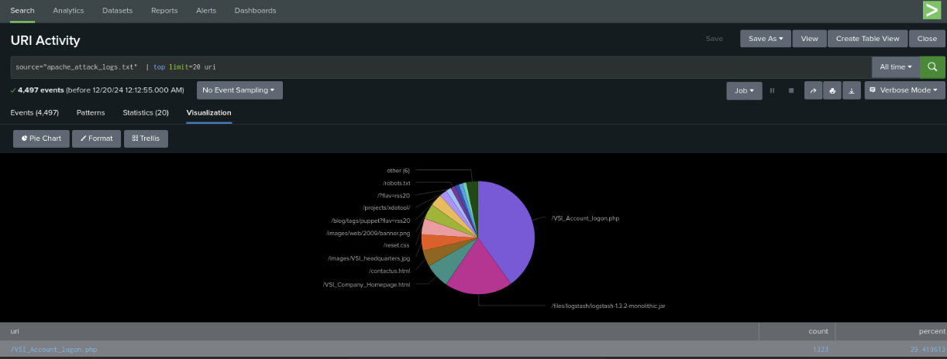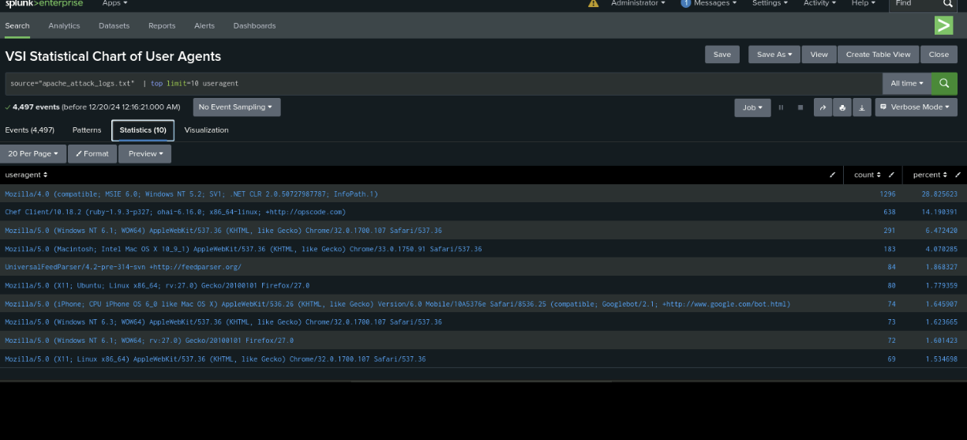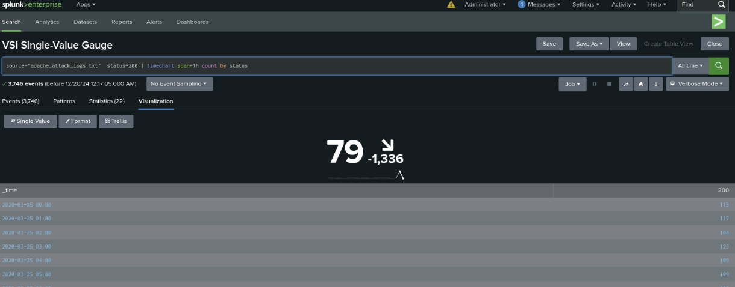

### **Part 2: Analyze Windows Attack Logs**

#### Report Analysis for Severity

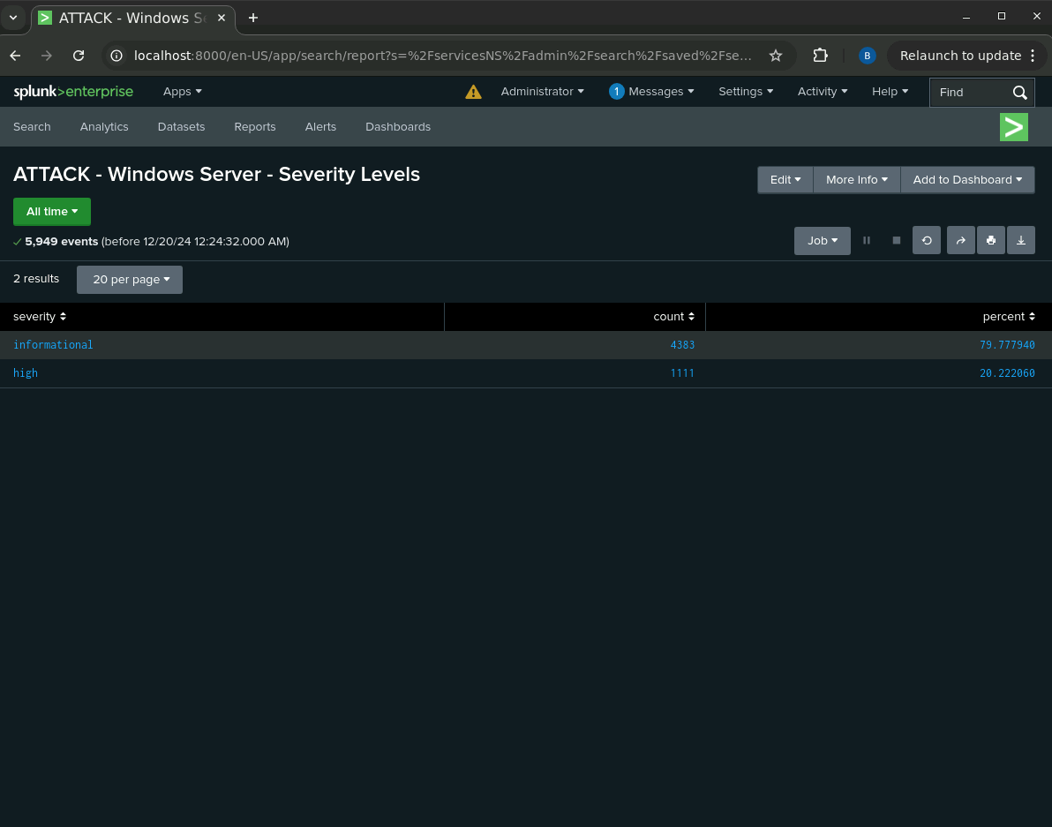

1. Review the updated results, and answer the following question in the [Project 3 Review Questions](https://docs.google.com/document/d/18JLq4dUf4zrL-6eqTNumXicpvpUDbHxPnZx2kOzwYoQ/edit?usp=sharing) document:
   * Did you detect any suspicious changes in severity?

Yes, the “high” severity count increased from 329 to 1111, a huge increase!

#### Report Analysis for Failed Activities

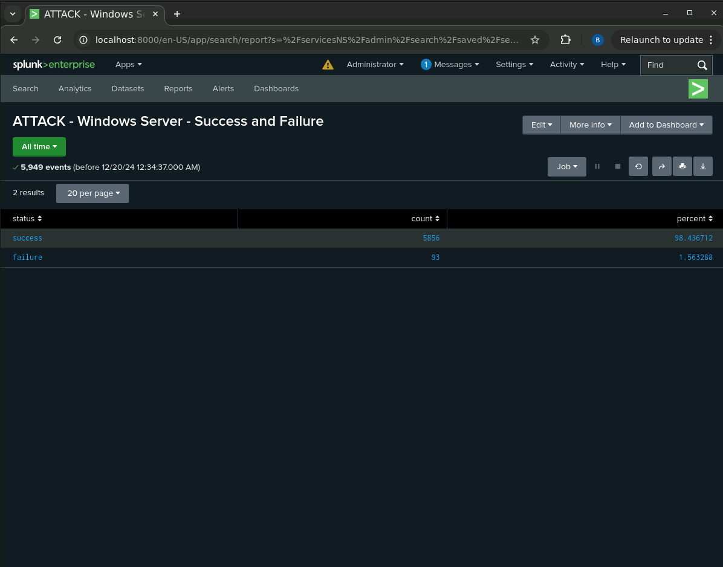

* + Did you detect any suspicious changes in failed activities?

Interestingly, the number of failures has decreased from our baseline to when under attack.

#### Alert Analysis for Failed Windows Activity

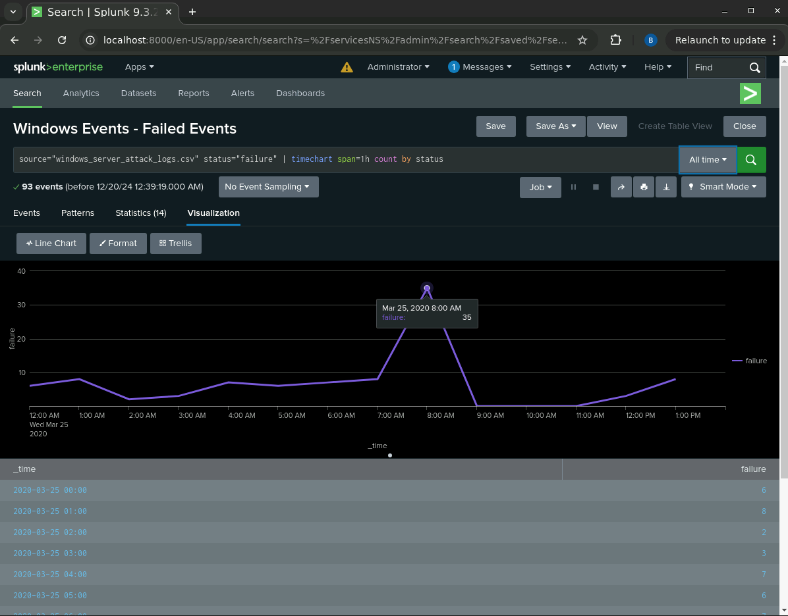

1. Review the updated results, and answer the following questions in the review document (*note that your alerts will not trigger; this is a theoretical exercise*):
   * Did you detect a suspicious volume of failed activity?

Yes, we noticed a suspicious volume of failed activity.

* + If so, what was the count of events in the hour(s) it occurred?

We noticed 35 failed events in a single hour, much higher than our previous baseline that had a maximum of 10 failed events an hour.

* + When did it occur?

The 35 failed events happened at 8:00AM on March 25, 2020.

* + Would your alert be triggered for this activity?

Our alert was set to be triggered if the count of failed events exceeded 12 failed events per hour (double our baseline failed event count), so yes, our alert would be triggered.

* + After reviewing, would you change your threshold from what you previously selected?

Knowing that during an actual attack, the volume will be much higher than our baseline, we would probably choose to raise our threshold a bit, such as to 15, just to avoid getting false positives if one day happened to have a slightly higher count of failed events, versus an actual attack with a higher volume of failed events.

#### Alert Analysis for Successful Logins

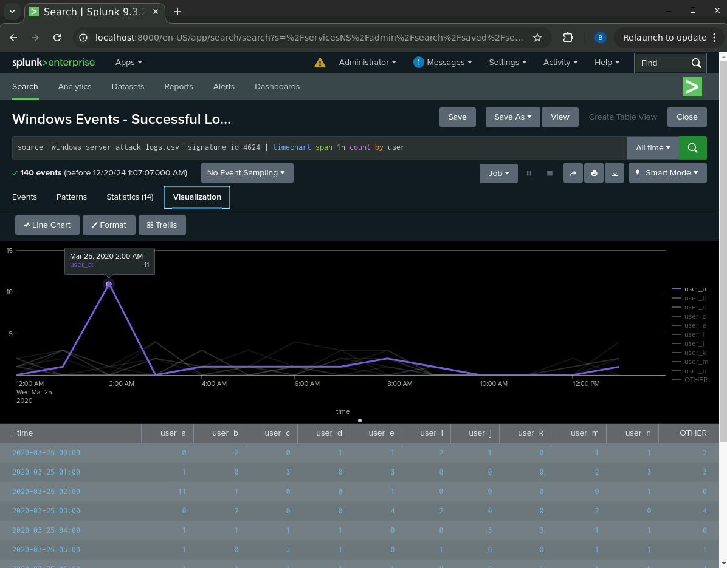

1. Review the updated results, and answer the following questions in the review document:
   * Did you detect a suspicious volume of successful logins?

Yes, we detected a suspicious volume of successful logins.

* + If so, what was the count of events in the hour(s) it occurred?

There were 11 successful logins.

* + Who is the primary user logging in?

The primary user logging in was user_a.

* + When did it occur?

It occurred at 2:00AM on March 25, 2020.

* + Would your alert be triggered for this activity?

Yes, our threshold was set to 8 successful logins per hour per user, so the 11 successful logins definitely would have triggered our alert.

* + After reviewing, would you change your threshold from what you previously selected?

No, in this case, I think our threshold was appropriate and it did successfully detect the intrusion. If we were going to improve the alert, rather than simply changing the threshold, it seems like it would be more useful to alert on “off hours” login attempts.

ExportEverything to an Amazon S3 bucket accomplishes a couple things for VSI:

1. It creates offsite cloud-based backups of the Splunk log files.
2. It allows us to change the output format to something that can be used more programmatically (such as JSON).
3. It allows other systems/analysts to access the logs via the cloud without affecting the real-time performance of the Splunk server.

